

**Web-Based Computer Hardware Purchasing and Troubleshooting Assistant Management**

**System**

G.P saNKALPA  
Bit Registration No: - R180527  
Index No: - 1805274

Name of the Supervisor:   
M.P. Sarath Wijesinghe

 **April 2022**



**This dissertation is submitted in partial fulfillment of the requirement of the Degree of Bachelor of Information Technology of the   
University of Colombo School of Computing.**

# Declaration

“I certify that this dissertation does not incorporate, without acknowledgement, any material previously submitted for a degree or diploma in any university and to the best of my knowledge and belief, it does not contain any material previously published or written by another person or myself except where due reference is made in the text. I also hereby give consent for my dissertation, if accepted, to be made available for photocopying and for interlibrary loans, and for the title and abstract to be made available to outside organizations.



Signature of Candidate: . . . . . . . . . . . . . . . . . . . . . . . Date: 29/01/2021

Name of Candidate: G.P Sankalpa

Countersigned by:

Signature of Supervisor(s)/Advisor(s): . . . . . . . . . . . . . . . . . . . . . Date: 29/01/2021

Name(s) of Supervisor(s)/Advisor(s): Mr. M.P.S.Wijesinghe

# Abstract

The computer sales and servicing industry sells and services a wide range of computers, including desktops, laptops, notebooks, palmtops, and software, as well as peripherals such as printers, scanners, and keyboards. Before being delivered to end users like homes and businesses, these products are often bought from makers and distributors in both domestic and foreign markets.

Under the present system of U-Star Digital, customers used to come into the store and communicate their demands to the technician who built their computer. Customers arrived at the store, gave over the defective item or computer to the technicians, and then waited in their restroom until the task was finished. They presently use a phone-based and WhatsApp-based order system to take online orders. There are no other options than bank transfers, and the customer must confirm the order with formal transaction documents. Due to a lack of adequate delivery information, customers are not given accurate delivery information.

The project's primary goal is to design and build an online platform for managing computer services and hardware that will assist the firm and its employees in growing their customer base and promoting their enterprise online.

For modeling, the system uses a client-server architecture and a non-object-oriented iterative software development process called Rational Unified Process. The system is designed using the Unified Modeling Language. For front-end development, PHP is utilized as the server-side programming language, along with HTML, JavaScript, and CSS. As an integrated development environment, the Microsoft Visual Studio Code is employed. The Apache web server is utilized and MySQL is used to manage the database. It may be used with a web browser on any GUI-based OS platform as this is a web-based system. This system has offered to meet the needs of the client. It will be quite beneficial in archiving their commercial objectives.

# Acknowledgements

Want to start by expressing my sincere gratitude to my supervisor, Mr. M.P. Sarath Wijeshinghe, Assistant Director - IT, Sri Lanka Export Development Board, for his unflagging support, helpful assistance, and consistent monitoring despite his busy schedule.

Mr.R.S.Kannangara, the owner of U-Star Digital, was also extremely helpful in gathering requirements and conducting user acceptance tests. I also like to thank the other U-Star Digital team members who volunteered their time to assist with domain-related information.

In order to use the knowledge from my degree programme, I'd want to thank the University of Colombo School of Computing, the Academic and Project Coordinators, and the Project Examination Board for Bachelor of Information Technology. I also want to sincerely thank all of my instructors for teaching me during my BIT degree programme.

Also owe thanks and appreciation who helped me out by offering suggestions for the user interfaces of the system and website. Finally, but certainly not least, I want to thankful to my parents for providing all of the materials needed for the project as well as for greatly inspiring and supporting me mentally to complete it.

Table Contents

Declaration ii

Abstract iii

Acknowledgements iv

List of Figures ix

List of Tables xii

List of Acronyms xiii

Chapter 1 – Introduction 1

1.1 Chapter Introduction 1

1.2 Introduction to U-Star Digital 1

1.3 Motivation of the Project 1

1.4 Objectives of the Project 2

1.5 Scope of the Project 2

1.5.1 Shopping Cart Module 2

1.5.2 Payment Module 2

1.5.3 Inventory Management Module 3

1.5.4 Delivery Management Module 3

1.5.5 Troubleshooting Assistant Module 3

1.5.6 Invoice Generating Module 3

1.5.7 User Management Module 3

1.5.8 Report Management Module 3

1.6 Structure of Dissertation 3

Chapter 2 – Analysis 5

2.1 Chapter Introduction 5

2.2 Fact Finding Techniques 5

2.2.1 Interviews 5

2.2.2 Observation 6

2.2.3 Existing Documents Analyzing 6

2.3 Existing System 6

2.4 Existing System Data Flow Diagram 6

2.5 Requirements Analysis 8

2.5.1 Functional Requirements 8

2.5.1 Non-Functional Requirements 9

2.6 Similar Systems and Literature Reviews 10

2.6.1 Microcenter 10

2.6.2 Newegg 11

2.6.3 Comparison of the Proposed System to a Comparable System 11

2.7 Model of the Proposed System's Process 12

2.7.1 Scrum 12

2.7.2 Extreme Programming (XP) 12

2.7.3 Rational Unified Process (RUP) 12

Chapter 3 – Design 15

3.1 Chapter Introduction 15

3.2 Alternate Solution 15

3.2.1 Stand-alone System 15

3.2.2 Collection of Software 15

3.2.3 Justification for Choosing a Web-Based System 15

3.3 The Architectural Design of the System 16

3.4 Diagram of the Use Case for the Proposed System 17

3.5 Use Case Narratives for the Proposed System 19

3.5.1 Use Case Narratives for Login Module 19

3.5.2 Use Case Narratives for Insert Inventory Item 20

3.6 ER Diagram for the Proposed System 21

3.7 Releational Shecma for System 22

3.8 Activity Diagrams for the Proposed System 23

3.8.1 Activity Diagram for Login 23

3.8.2 Activity Diagram for Add Item 23

3.9 – UI Designs for the Proposed System 24

3.9.1 – Customer Login and Register Form UI Design 24

3.9.3 – Customer Checkout UI Design 25

3.9.3 – Add Inventory Item Form 26

Chapter 4 – Implementation 27

4.1 – Chapter Introduction 27

4.2 – Implementation Environment 27

4.2.1 – Software Environment 27

4.2.2 – Hardware Environment 28

4.2.3 – Other Software and Development Tools 28

4.3 – Justification for the choice of the implementation platform 28

4.3.1 System File Structure 30

4.4 – High Level Module Structure 30

4.5 – Major Code Segments 31

4.5.1 – Customer Checkout Code Segments 34

4.6 – Reused Existing Codes 35

Chapter 5 – Evaluation 39

5.1 – Introduction 39

5.2 - Description of testing approach 39

5.3 - Test strategy 39

5.3.1 - Verification and Validation 40

5.3.2 - Testing Process 40

5.5 - User Acceptance Testing 43

5.6 - User Evaluation 43

Chapter 6 – Conclusion 47

6.1- Introduction 47

6.2 - Critical evaluation of the project 47

6.3 - Lesson learned 47

6.4 - Future work 48

References 50

Appendix A – System Manual 51

Appendix B – Design Documentation 54

Appendix C – User Manual 66

Appendix D – Management Reports 75

Appendix E – Test Results 78

Appendix F – Client Certificate 85

Glossary 86

Index 87

# List of Figures

Figure 2. 1: Data Flow Diagram for the Existing System. 7

Figure 2. 2: Interface Design of Microcenter Similar System 10

Figure 2. 3: Interface Design of NewEgg Similar System 11

Figure 3. 1 System Implementation Architectural Design 17

Figure 3. 2 Proposed System Use Case Diagram 18

Figure 3. 3: ER Diagram for Proposed System 21

Figure 3. 4: Activity Diagram for Login 23

Figure 3. 5: Activity Diagram for Add Item 23

Figure 3. 6: Login Form UI Design 24

Figure 3. 7: Order Checkout form 25

Figure 3. 8: Add Items form 26

Figure 4. 1: Hardware Environment 28

Figure 4. 2: File Structure 30

Figure 4. 3 Member Registration Code Segments 31

Figure 4. 4 Basic Validation Code Segment 32

Figure 4. 5 Advanced Validation Code Segment 33

Figure 4. 6 Customer Checkout Code Segment 34

Figure 4. 7 Reusable CSS Files 35

Figure 4. 8 Reusable Javascript files 35

Figure 4. 9 Reusable Image Upload Function 36

Figure 4. 10 Reusable Data Clean Function 37

Figure 4. 11 Reusable Main Menu Code Segment 37

Figure 4. 12 Reusable Sub Menu Code Segments 38

Figure 5. 1: User Feedback Form 44

Figure 5. 2: User Acceptance Test Evaluation Sample 45

Figure 5. 3: Summary of User Feedback Evaluation 46

Figure A. 1: XAMMP Server Download Page 52

Figure A. 2: Create Database 52

Figure B. 1: Use Case Diagram for Customer Registration 54

Figure B. 2: Use Case Diagram for Order Checkout 56

Figure B. 3 Use Case Diagram for Update Courier Details 58

Figure B. 4 Use Case Diagram for Make Payments 59

Figure B. 5 Use Case Diagram for Check Items 60

Figure B. 6: Activity Diagram for Customer Login 61

Figure B. 7: Activity Diagram for Order Checkout 62

Figure B. 8 Activity Diagram for Update Courier Details 63

Figure B. 9 Activity Diagram for Make Payments 64

Figure B. 10 Activity Diagram for Check Items 65

Figure C. 1: Home Page 66

Figure C. 2: Category Page 67

Figure C. 3: List Item Page 67

Figure C. 4: Item Page 68

Figure C. 5: Cart Page 68

Figure C. 6: Checkout Page 69

Figure C. 7: Invoice Page 70

Figure C. 8: Add Category Form 71

Figure C. 9: Add Brand Form 71

Figure C. 10: Add Models Form 71

Figure C. 11: Add Items Form 72

Figure C. 12: Add Employee 73

Figure C. 13: Add user modules 74

Figure D. 1: Report of Orders 75

Figure D. 2: Report of Items 75

Figure D. 3: Report of Order Deliveries 76

Figure D. 4: Report of Stock 76

Figure D. 5: Report of Product Categories 77

Figure E. 1: User Acceptance Test Result One 82

Figure E. 2: User Acceptance Test Result Two 83

Figure E. 3: User Acceptance Test Result Three 83

Figure E. 4: User Acceptance Test Result four 84

# List of Tables

Table 2. 1: Stakeholders Interview Schedule 5

Table 2. 2: Comparison between Proposed System and Similar Systems 12

Table 2. 3: Comparison between Different Process Models 14

Table 3. 1: Use Case Narrative for Login Module 19

Table 3. 2: Use Case Narrative for Inventory Item 20

Table 5. 1: Test Case for Customer Registration 42

Table 5. 2: Test Results for Customer login 42

Table 5. 3: Test Result for Checkout Process 43

Table A. 1: Hardware Requirements 51

Table A. 2: Software Requirements 51

Table B. 1: Use Case Narrative for Customer Registration 56

Table B. 2: Use Case Narrative for Order Checkout 57

Table B. 3 Use Case Narrative for Update Courier Details 58

Table B. 4 Use Case Narrative for Make Payments 59

Table B. 5 Use Case Narrative for Check Items 61

Table E. 1: Test Result for Customer Registration 79

Table E. 2: Test Result for Customer Login 79

Table E. 3: Test Result for Checkout Process 82

# List of Acronyms

**AJAX** – Asynchronous JavaScript and XML

**BIT** – Bachelor of Information Technology

**CC** – Creative Cloud

**CD** – Compact Disc

**CSS** – Cascading Style Sheets

**ER** – Entity Relationship

**FIFO** – Frist In Frist Out

**HTML** – Hypertext Markup Language

**ICT** – Information Communication Technology

**IDE** – Integrated Development Environment

**PEB** – Project Evaluation Board

**PHP** – PHP Hypertext Preprocessor

**RUP** – Rational Unified Process

**SQL** – Structured Query Language

**UAT** – User Acceptance Testing

**UCSC** – University of Colombo School of Computing

**UI** – User Interface

**UX** – User Experience

**UML** – Unified Modeling Language

**URL** – Uniform Resource Locator

**XAMMP** – Apache + Maria DB + PHP + Perl

**XP** – Extreme Programming

# Chapter 1 – Introduction

## 1.1 Chapter Introduction

This chapter provides an overview of U-Star Digital and the client's planned system. This will also cover the background and rationale for starting the project, as well as the project scope and objectives, and also the dissertation format.

## 1.2 Introduction to U-Star Digital

Many types of computers, including desktops, laptops, notebooks, palmtops, and software, as well as peripherals like printers, scanners, and keyboards, are sold and serviced in the computer sales and servicing industry. Before being supplied to end-users, such as households and businesses, these products are frequently purchased from domestic and international producers and distributors.

U-Star Digital is a renowned information and communication technology (ICT) company that has been in existence since 2010. They provide an unrivaled program and experience in ICT equipment repair, servicing, maintenance, and cleaning. They rely on its technologically cutting-edge next-generation infrastructure to produce best in class lifestyle-enhancing and customer-aware goods and services that account for customers' needs.

## 1.3 Motivation of the Project

Customers used to come into the store and convey their needs to the technician who built their computer under the old system. Customers arrived at the shop, handed over the defective item or computer to the hardware professionals, and then waited in their restroom until the job was completed. To take online orders, they currently utilize a phone-based and WhatsApp-based order system. There are no other options than bank transfers, and the customer must send legal transaction paperwork to confirm the order. Customers are not given accurate delivery information due to a lack of appropriate delivery information.

Customers are mobile, busy, and always on the go. They want frictionless and seamless services. Developing a thorough understanding of consumer demands they are provided with a convenient product browsing experience, a simple payment system, and a delivery tracking system that allows customers to track their order as it arrives at their home.

An outstanding solution for U-Star Digital to continue their greatness in the computer sales and maintenance sector in this digital age can be added. By the same token, while pursuing a Bachelor's degree in Information Technology, this effort would substantially assist me in improving my project management, system analysis, design, and development abilities.

## 1.4 Objectives of the Project

The study's overall goal is to build and develop an online system for managing computer hardware and services that will assist the company and its employees in becoming more popular with their consumers and marketing their business through the internet.

The study's particular objectives are as follows:

* Providing a feature-rich product browsing method, as well as a simple payment and delivery mechanism, to fulfill the customer's order.
* Inventory management, which makes it easy to manipulate items for the store and receive automated alerts when stock levels are low.
* Generate a variety of reports and graphics, including sales and stock data, to assist management in making decisions.
* Using an automated question-based module to implement Online Troubleshooting, and suggest the appropriate solution for resolving the problem.

## 1.5 Scope of the Project

Web-Based Computer Hardware Purchasing and Troubleshooting Assistant management system has a broad reach that includes the following points of view.

### 1.5.1 Shopping Cart Module

This module allows users to find the entire store for items and create customer orders using a shopping cart.

### 1.5.2 Payment Module

This module provides up-to-date information on all payments made by customers, as well as advanced payment filtering options and having bank transfers, and cash on delivery options.

### 1.5.3 Inventory Management Module

Has the ability to handle the complete inventory. Individual items and corresponding categories, brands, and models can be added, deleted, and updated.

### 1.5.4 Delivery Management Module

This module contains all of the customer-created delivery records in the system. It displays the order tracking number as well as information about the courier company.

### 1.5.5 Troubleshooting Assistant Module

With the help of this virtual assistant, consumers may troubleshoot their hardware failures with the most acurate videos and the description.

### 1.5.6 Invoice Generating Module

In the system, this module generates a variety of invoices. It's compatible with the payment, computer hardware assistant, and troubleshooting modules.

### 1.5.7 User Management Module

This module helps to manage all of the users of the system. It aids in the selection of the right individual for the right position.

### 1.5.8 Report Management Module

This module will make it possible to generate, preview, and print a variety of reports in order to continue with the success of the business.

The warranty claim option and the work card for the repair of the computer parts were the projects that went outside of the bounds. Additionally, it creates a link to the troubleshooting form, making it simple to schedule appointments for warranty and repair inspections.

## 1.6 Structure of Dissertation

The introduction is the first of six chapters in the dissertation. Below is a brief list of each chapter's contents.

Chapter 1 – Introduction

The project's goals and scope are explained in this chapter. It also explains the present system's flaws and what motivates the creation of this system.

Chapter 2 – AnalysisThis chapter covers requirement collection strategies for a new system's functional and non-functional criteria, as well as analysis approaches for understanding the existing system.

Chapter 3 – Design

The system's design, including database and user interface design, is covered in this chapter. To make the system's structure easier to understand, additionally this chapter includes top-level and module-level usage examples.

Chapter 4 – Implementation

The structure of important code modules is covered in this chapter along with implementation technologies, hardware, and software specifications.

Chapter 5 – Evaluation

This chapter describes the test cases used to evaluate the system and the results. It gives a description of the use cases and test cases.

Chapter 6 – Conclusion

This chapter summarises the key takeaways and offers ideas for improving the system going forward.

A general index and a glossary of terms are also included.

# Chapter 2 – Analysis

## 2.1 Chapter Introduction

The process of identifying the underlying problem and comprehending the problem domain from a jumble of facts and figures is known as analysis. The purpose of the analysis is to provide a complete, consistent, and unambiguous image of the system. Also, what should the system supply to meet all user requirements. Requirements Engineering is another name for this procedure. The system can be designed with the help of analysis.

## 2.2 Fact Finding Techniques

To accurately describe and interpret system requirements, fact-gathering techniques are information-gathering techniques used in system analysis. The following strategies were primarily employed:

1. Interviews
2. Observation
3. Existing Documents Analyzing

### 2.2.1 Interviews

The initial technique utilized to collect and establish system requirements, as well as clarify and confirm those needs, was an interview. In order to effectively address and weigh the inputs of each interviewee, the interviewer must first comprehend the perspective of each interviewee.

The following is the interview schedule that was used (Table 2.1).

|  |  |  |  |
| --- | --- | --- | --- |
| **Date** | **Interviewee** | **Position** | **Interview Duration** |
| 23/10/2021 | Mr. Samudu Kannangara | Owner | 40 minutes |
| 23/10/2021 | Mr. Upali Kannangara | Stock Keeper | 30 minutes |
| 23/10/2021 | Mr. Thamara Kannangara | Technician | 40 minutes |
| 25/10/2021 | Mr. Susith Sewikrama | Delivery Manager | 20 minutes |
| 25/10/2021 | Mr. Chamara Perera | Technician | 30 minutes |
| 27/10/2021 | Miss. Kalpani Dinusha | Customer | 20 minutes |

Table 2. 1: Stakeholders Interview Schedule

### 2.2.2 Observation

Observation is a fact-finding technique in which system analysts observe how individuals perform tasks and activities during site visits. This is an excellent approach to learn what end users go through in their day-to-day processes, and it gives you a lot of insight into the business process.

### 2.2.3 Existing Documents Analyzing

Analyzing existing papers is a key strategy for acquiring requirements. When building a user-friendly system, evaluating the papers and reports of an existing system can help. Solid information and facts are usually collected by studying existing papers, which helps to corroborate and validate the requirements gathered through other methods.

## 2.3 Existing System

From the beginning, U-Star Digital has used a semi-paper-based manual approach. During the system analysis phase, it was discovered that the current system can only perform a limited number of functions.

Customers used to come into the store and convey their needs to the technician who built their computer under the old system. Customers arrived at the shop, handed over the defective item or computer to the hardware professionals, and then waited in their restroom until the job was completed. To take online orders, they currently utilize a phone-based and WhatsApp-based order system. There are no other options than bank transfers, and the customer must send legal transaction paperwork to confirm the order. Customers are not given accurate delivery information due to a lack of appropriate delivery information.

## 2.4 Existing System Data Flow Diagram

There were numerous downsides to the paper-based technique.

* It was discovered that data was repeating.
* Data that is unidentifiable owing to illegible handwriting.
* Data was lost because of misplacing the recording materials.
* It takes a long time.
* Manual computations are required.
* Data security is lacking.
* More manpower is required.

The following data flow diagram illustrated by existing system (Figure 2.1).

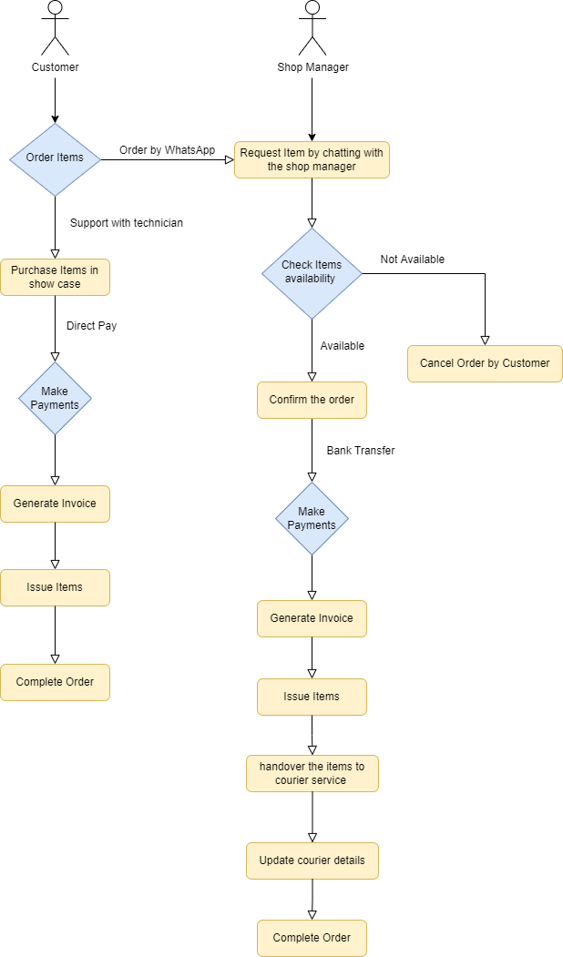

*Figure 2. 1: Data Flow Diagram for the Existing System.*

## 2.5 Requirements Analysis

### 2.5.1 Functional Requirements

Calculations, data insertion, manipulation, and processing, as well as data presentation, are all defined by functional requirements. The system's required features are listed below.

* **Shopping Cart**
  + Customer search and select items to add to the cart.
  + Customers can make the order in the selected items in the cart.
  + Calculates selected items' totals and discounts.
  + Orders are recorded in the Customer Dashboard Orders section and Shop Managers Orders section.
  + Able to update order status.
  + Notify the shop manager of a new order.
* **Payment**
  + Customers can select the payment method.
  + Carry the order totals to the payment method.
  + Proceed to checkout with total payment.
* **Inventory Management** 
  + Insert, update and delete the Items, Brands, Models, and Item Specifications.
  + Notify with low stock and out-of-stock Items.
  + Able to create a low stock threshold.
  + Able to create discounts with a selected number of date periods.
* **Delivery Management** 
  + Able to create courier companies.
  + Customers can notify with courier company details and order tracking numbers when the order is dispatched.
  + Customers can view their order details by giving the courier company a tracking URL using the tracking number.
  + Customers were able to update the courier process when receiving the item.
* **Troubleshooting Assistant**
  + Customers select the type of defect.
  + Load appropriate answer form already configerd in the database.
  + Show the answers related to the customer selected answer.
* **Invoice Generation** 
  + Calculate order totals and courier payment and generate an invoice for the customer.
  + Invoices can filter with the selected date range.
  + Invoices can export and have the ability to print.
* **User Management**
  + Able to manage all of the users of the system.
  + Aids to create user roles and permission.
* **Report Management**
  + This module will make it possible to generate, preview, and print a variety of reports.
  + Able to export and filter the reports within the selected time frame.

### 2.5.1 Non-Functional Requirements

Non-functional requirements had to be met in order for a system to be valuable and successful.

* **Usability**

The system is directly connected to all of the shop's consumers. Users of the system can access necessary reports over the internet. Giving clients better service means making data easier to access and sending notifications about existing purchases.

* **Maintainability**  
  It's simple to correct a bug, add new features, make changes to support new operating systems, and make the software easier to maintain for others. It also improves the contentment of members.
* **Performance**

The system should be quick and finish the task in the shortest time possible. Data should be retrieved as soon as feasible, and the response time should be minimal.

* **Security**

Being that the system saves client personal data including e - mail addresses, contact information, and mailing addresses, security is the major concern for the system to shield users' sensitive data.

* **Reliability and accuracy**

The system's major features include the generation of progress reports and workout programs. As a result, the system's accuracy and dependability are critical.

## 2.6 Similar Systems and Literature Reviews

It was required to examine the existing system before designing the web-based Computer Hardware Purchasing and Troubleshooting Assistant management system. Because the current system is semi-paper-based, a literature review and related system analysis were also decided. The systems listed below were evaluated in order to have a thorough understanding of the situation.

### Graphical user interface Description automatically generated2.6.1 Microcenter

Figure 2. 2: Interface Design of Microcenter Similar System

“More computers, electronics, networking, and communication devices are available at Micro Center than from any other company more than 30,000 items are in stock. Micro Center is incredibly passionate about offering products and services for supporting technology. Since 2010, we have provided in-store pickup for online orders.” [1]

### 2.6.2 Newegg

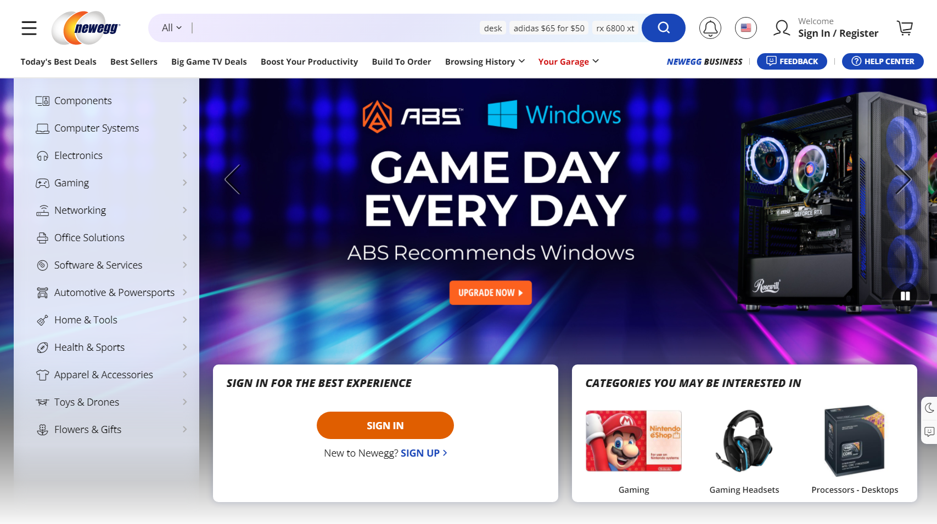

Figure 2. 3: Interface Design of NewEgg Similar System

“Today, millions of customers turn to Newegg to shop for the latest PC components, consumer electronics, smart home and gaming products. Newegg is consistently ranked as one of the best online shopping destinations, and the company regularly earns industry-leading customer service ratings.” [2]

### 2.6.3 Comparison of the Proposed System to a Comparable System

The suggested system and the related systems that were mentioned were very similar. The system's primary benefit was the ability to repair a user's computer without having to go to a computer hardware store.

When compared to the micro centre and the system, the computer hardware assistant is the more alluring feature. It enables customers to construct their computers virtually and obtain construction quote prices.

Below are some examples of similar systems' most prominent components. (Table 2.2)

|  |  |  |  |
| --- | --- | --- | --- |
| **Functionality** | **Proposed System** | **Microcenter** | **NewEgg** |
| Shopping Cart | Yes | Yes | Yes |
| Payment Management | Yes | Yes | Yes |
| Inventory Management | Yes | Yes | Yes |
| Delivery Management | Yes | Yes | Yes |
| Troubleshooting Assistant | Yes | No | No |
| Computer Hardware Assistant | No | Yes | No |
| Mobile App | No | No | Yes |

Table 2. 2: Comparison between Proposed System and Similar Systems

## 2.7 Model of the Proposed System's Process

The organisation of software development activity into phases for better design, project management, and product management is known as the software development process, sometimes known as the software development lifecycle.

Scrum, Extreme Programming (XP), RUP, and other process models exist for developing software systems.

### 2.7.1 Scrum

“The Scrum process organizes development into a sequence of sprints, each of which results in a potentially usable product with an added increment of function. The tasks for each sprint are set, in consultation with a stakeholder representative, during a sprint planning meeting and cannot be added to during the sprint. Each task is typically expressed as a user story. Each sprint is time boxed: the end date of the sprint does not change. Tasks that cannot be accomplished in time are returned by the team to the backlog for future consideration.” [3]

### 2.7.2 Extreme Programming (XP)

“Extreme Programming (XP) is an agile software development framework that aims to produce higher quality software, and higher quality of life for the development team. XP is the most specific of the agile frameworks regarding appropriate engineering practices for software development.” [4]

### 2.7.3 Rational Unified Process (RUP)

"Rational Unified Process" is what it stands for. RUP is a method for creating software that was created by IBM's Rational division. The development process is divided into four separate phases, each of which includes business modelling, analysis and design, implementation, testing, and deployment. There are four phases:

1. **Inception -** The project's concept is presented. The project's development team decides if it is worthwhile to pursue it and what resources will be required.
2. **Elaboration -** The architecture of the project and the needed resources are assessed further. The software's potential uses and development expenses are taken into account by the developers.
3. **Construction -** The project has been created and finished. The programme has been created, developed, and tested.
4. **Transition -** The world can now use the software. Final modifications or upgrades are done in response to customer feedback.

Companies can develop software products in an organised manner using the RUP development approach. It helps avoid resource waste and lowers unforeseen development expenses by providing a detailed strategy for each stage of the development process.” [5]

Based on the considerations outlined in Table 2.3 over various strategies, the Rational Unified Process (RUP) was selected as the most effective process model for the suggested system.

There were further justifications for choosing the RUP for the mythology of system development. The client's requirements are stable during requirement collection. The project scope is fixed as a result. Analyzing the requirements revealed that the project would be substantially larger than anticipated. The planning phase was the most beneficial. The milestones were the driving force. The project required the documentation procedure. The RUP contributes to maintaining the precise documentation necessary for the project's success.

|  |  |  |
| --- | --- | --- |
| **RUP** | **Scrum** | **XP** |
| A good option for a huge, long-term project. | There is no set termination date. At the end of the current iteration, the next iteration plan is determined. | Release regularly. |
| The planning process is driven by the end date and includes intermediate milestones. | Scrum employs a project backlog instead of a scope. | A shorter time limit |
| Requirements are fixed | It's ideal for rapid upgrade tasks that don't have to be completed by a certain date. | Expecting adjustments in requirements. |
| The scope of the project is predetermined. | Documentation is severely limited. | There is a lack of general design. |
| Documentation is required. |  | There is little to no documentation. |

Table 2. 3: Comparison between Different Process Models

# Chapter 3 – Design

## 3.1 Chapter Introduction

The overall structure of the suggested system is covered in the design chapter. The database of the system, relevant Use Case Diagrams, Entity Relationship Diagrams, and other UML Diagrams, as well as the tools, methodologies, and design procedures utilised in the design phase are all described in this chapter.

## 3.2 Alternate Solution

Alternatives to the Web-Based Computer Hardware Purchasing and Troubleshooting Assistant management system include a mobile application, the use of a software collection, or the continued use of the current manual system.

### 3.2.1 Stand-alone System

Software that is not bundled with another programme and can be used without an internet connection is known as stand-alone software (work offline). It is not very useful for the Web-Based Computer Hardware Purchasing and Troubleshooting Assistant management system because outdoor service management cannot be carried out without the use of the internet, it is more expensive, and installation and maintenance are more difficult than with a Web-Based System.

### 3.2.2 Collection of Software

The applications in the following list may be helpful in managing the Computer Hardware Purchasing and Troubleshooting Assistant management system.

* Computer Hardware Assistant can help the lack of knowledge customers to select the perfect item to build their computer.
* Inventory can manage individual objects as well as their corresponding categories, brands, and models.

### 3.2.3 Justification for Choosing a Web-Based System

The web-based system outperformed the standalone system in several ways. because the characteristics of online shopping carts were the project's declared scope. It's simple to keep track of the system's progress from any location. The system would be platform-independent. Because the database is centralized and everything is synchronized, maintenance is simple. Allow users to access the system at any time and from any location. It also allows for the usage of a wide range of devices to access the system.

## 3.3 The Architectural Design of the System

As a Procedural Programming Design Concept, the system will be developed utilizing the Non-Object Oriented technique.

In a procedural language, a program is a list of statements, each of which instructs the computer to perform a certain task. It concentrates on the technique (function) and algorithm that are required to complete the derived computation. When a program grows in size, it is divided into functions, each with a distinct purpose. One of the fundamentals of structured programming is the division of the program into functions and modules.

Procedural-oriented programming has several characteristics.

* The emphasis is on getting things done (Functions).
* The program is divided into many functions.
* Passing parameters across functions allows them to communicate with one another.
* Global variables are shared between functions.
* The procedure calls are based on the notion.
* When it comes to program design, it takes a top-down approach.

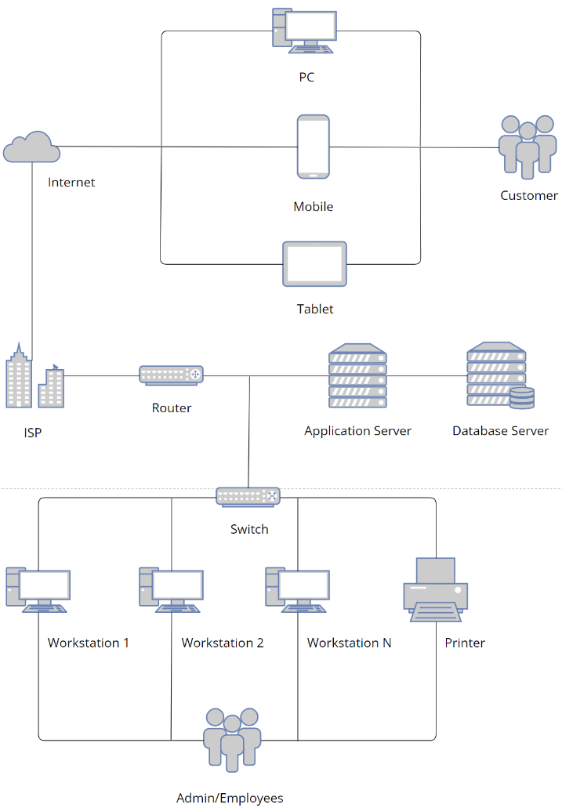The system implementation architectural design (Figure 3.1)

Figure 3. 1 System Implementation Architectural Design

## 3.4 Diagram of the Use Case for the Proposed System

The following is a high-level Use Case Diagram for the Proposed System.

The system's actors:

**Admin:** Create users and manage user permissions in the system.

**Shop Manager:** Manage all the orders made by the customers.

**Inventory Manager:** Manage the inventory of the store.

**Delivery Manager:** Manage all deliveries and register new courier companies

**Technician:** Match the computer hardware and manage the troubleshooting questions.

**Customer:** Make orders.

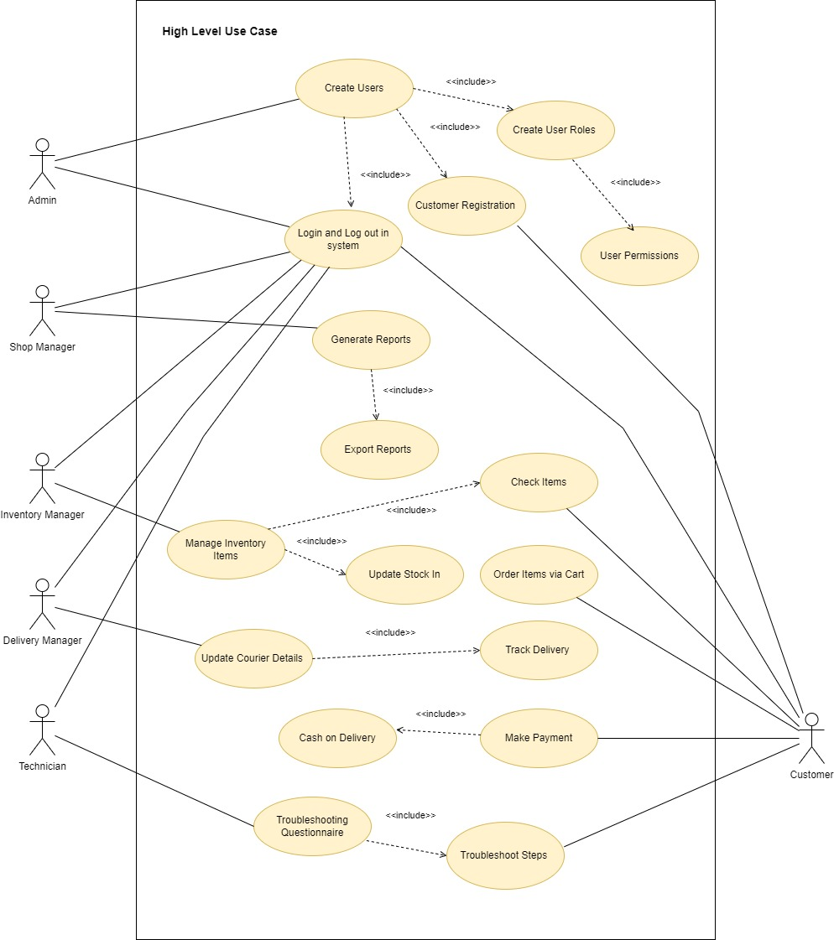

Figure 3. 2 Proposed System Use Case Diagram

## 3.5 Use Case Narratives for the Proposed System

The development of several system sections is guided by the use case narratives that follow. The most important narratives are only added in this part. There are more narratives added to section B of the appendix.

### 3.5.1 Use Case Narratives for Login Module

The login module's whole use case narrative (Table 3.1)

|  |  |  |
| --- | --- | --- |
| **Use-case Number** | UC-04 | |
| **Use-Case Name** | Login | |
| **Priority** | High | |
| **Actor** | Admin, Shop Manager, Inventory Manager, Delivery Manager, Technician, Customer | |
| **Description** | This use case explains how customers and shop employees log into the system. | |
| **Precondition** | All actors are properly registered to the system. | |
| **Post-condition** | If the use case was successful, the actor is now logged into the system. If not, the system state is unchanged. | |
| **Basic course of Action** | **User Action** | **System Response** |
| 1. The Actor is on the login page to log in to the system.  3. The actor click the "Login" button after entering his username and password. | 2. Actor is encouraged by the system to input their username and password.  4. The system verifies that all the filled have been filled out and are valid.  5. The system was able to log in successfully.  6. Use case Exit |
| **Alternate course of Action** | 4.1 The system alerts the user with the message "Invalid Username or Password" and then proceeds to step 3 of the basic course of action to input again if all fields are not filled out and do not match the username and password. | |

Table 3. 1: Use Case Narrative for Login Module

### 3.5.2 Use Case Narratives for Insert Inventory Item

The insert inventory item module's whole use case narrative (Table 3.2)

|  |  |  |
| --- | --- | --- |
| **Use-case Number** | UC-08 | |
| **Use-Case Name** | Insert Inventory Item | |
| **Priority** | High | |
| **Actor** | Inventory Manager | |
| **Description** | How to manage inventory items is explained in this use case. | |
| **Precondition** | None | |
| **Post-condition** | The actor can add the product to the system and configure it to sell to clients if the use case was successful. | |
| **Basic course of Action** | **User Action** | **System Response** |
| 1. Actor clicks the “Add Item” in the Item Management section.  3. Actor fill the fields (Item Image, Item Name, Category, Brand, Model, SKU number, Insert variable specifications, reorder level, Unit price, and Sale price)  4. Actor click “Insert Item” | 2. System prompts the form to insert details to the actor.  5. System validates the Item Name and SKU already in the system.  6. System display massage “New Item Insert” |
| **Alternate course of Action** | 5.1. If an item is already inserted into the system display the popup message “This Item Already in the System”. | |

Table 3. 2: Use Case Narrative for Inventory Item

## 3.6 ER Diagram for the Proposed System

The high-level ER Diagram below depicts the relationships between the proposed system's constituents. (Figure 3.3)

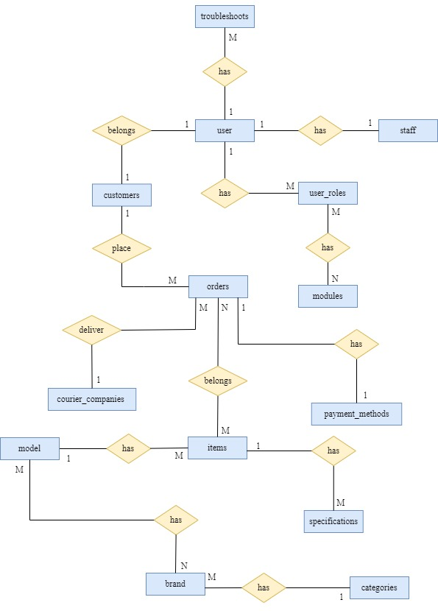  
  
Figure 3. 3: ER Diagram for Proposed System

## 3.7 Releational Shecma for System

* USERS (user_id, user_name, email, password, frist_name, last_name, profile_image, created_date, status*, user_role*, u_notification*)
* CUSTOMERS (cus_id, contact_number, postal_code, address_l1, address_l2, city, province, user_id*)
* STAFF (staff_id, nic, dob, contact_number, address_l1, address_l2, city, postal_code, user_id*, status*)
* USER_ROLES (user_role_id, role_name, status*)
* TROUBLESHOOTS (troub_id, trub_name, trub_discription, trub_video)
* MODULES (module_id, description, path, view, icon, status*)
* ORDERS (order_id, order_number, order_total, total_discount, grand_total, order_date, order_time, user_id*, delivery_charge*, payment_id*, courier_status*)
* PAYMENT_METHODS (id, name, discription)
* COURIERS_ COMPANIES (company_id, company_name, contact_number, contact_number_opp, email, address_line_1, address_line_2, tracking_url, status*)
* ITEMS (item_id, item_image, item_name, sku, reorder_level, grn_price, unit_price, sale_price, sale_price, discount_rate, item_discription, date, stock,warranty_period, category_id*, brand_id*, model_id*, status*)
* SPECIFICATIONS (spec_id, spec, category_id*, status*)
* MODELS (model_id, model_name,category_id*, status*)
* BRANDS (brand_id, brand_name, status*)
* CATEGORIES (category_id, category_name, category_discription, cat_image, status)

## 3.8 Activity Diagrams for the Proposed System

### 3.8.1 Activity Diagram for Login

The activity diagram for creating workouts is shown in Figure 3.4.

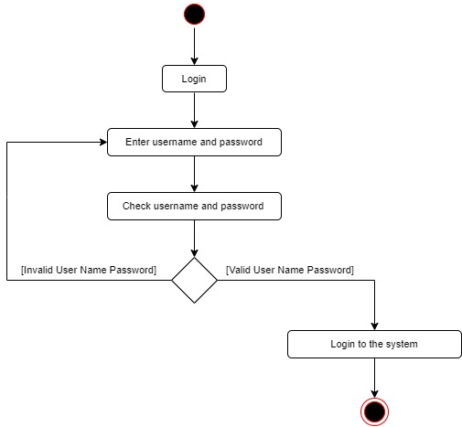  
  
Figure 3. 4: Activity Diagram for Login

### 3.8.2 Activity Diagram for Add Item

The activity diagram for adding a new item to the inventory is shown in Figure 3.5.

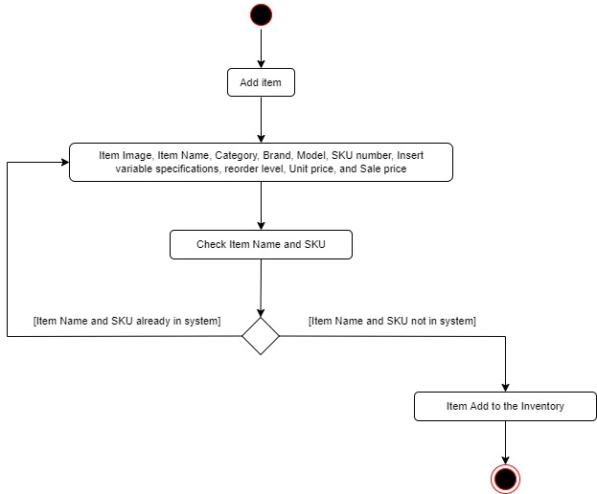  
  
Figure 3. 5: Activity Diagram for Add Item

## 3.9 – UI Designs for the Proposed System

### 3.9.1 – Customer Login and Register Form UI Design

Customer my account login and register form (Figure 3.6)

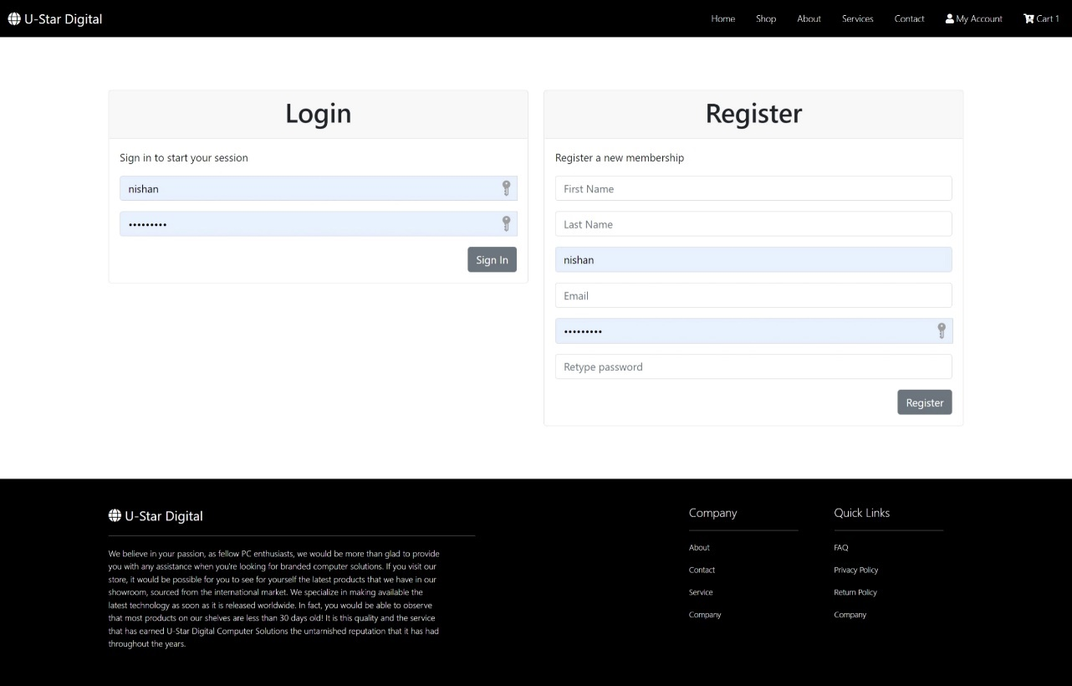

Figure 3. 6: Login Form UI Design

### 3.9.3 – Customer Checkout UI Design

Checkout page full view of the UI design (Figure 3.7)

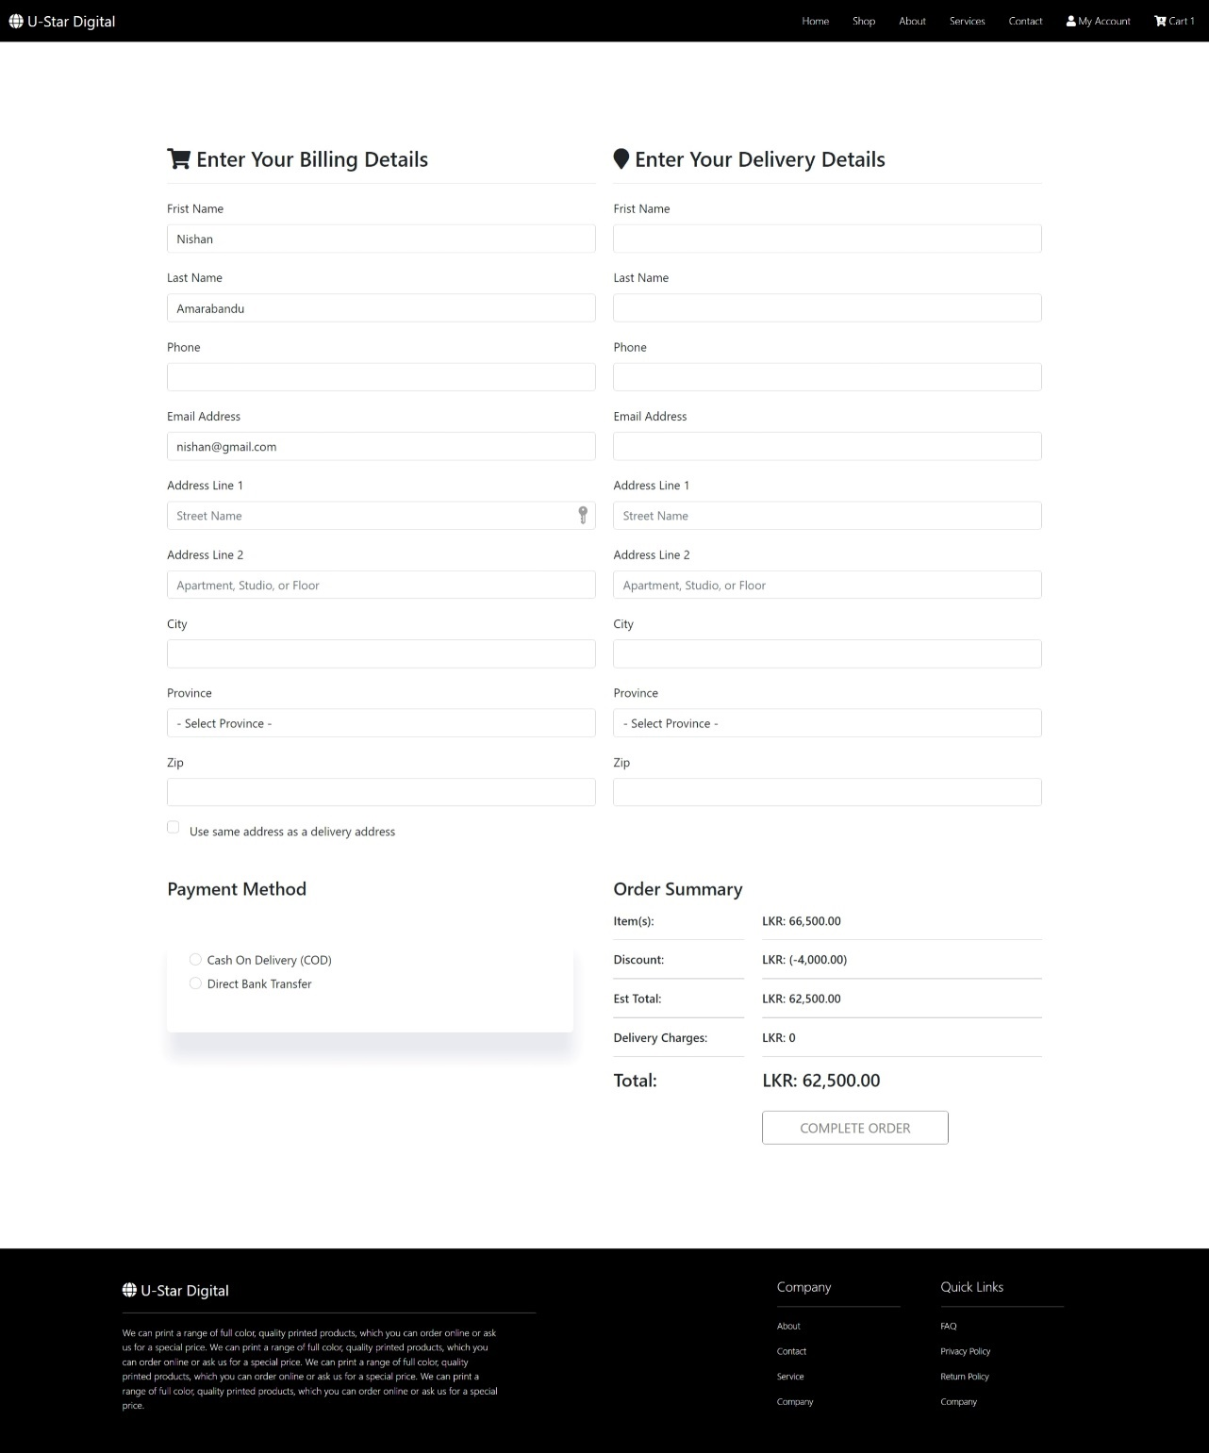

Figure 3. 7: Order Checkout form

### 3.9.3 – Add Inventory Item Form

The form displays the inventory management user interface for adding products to the inventory (Figure 3.8).

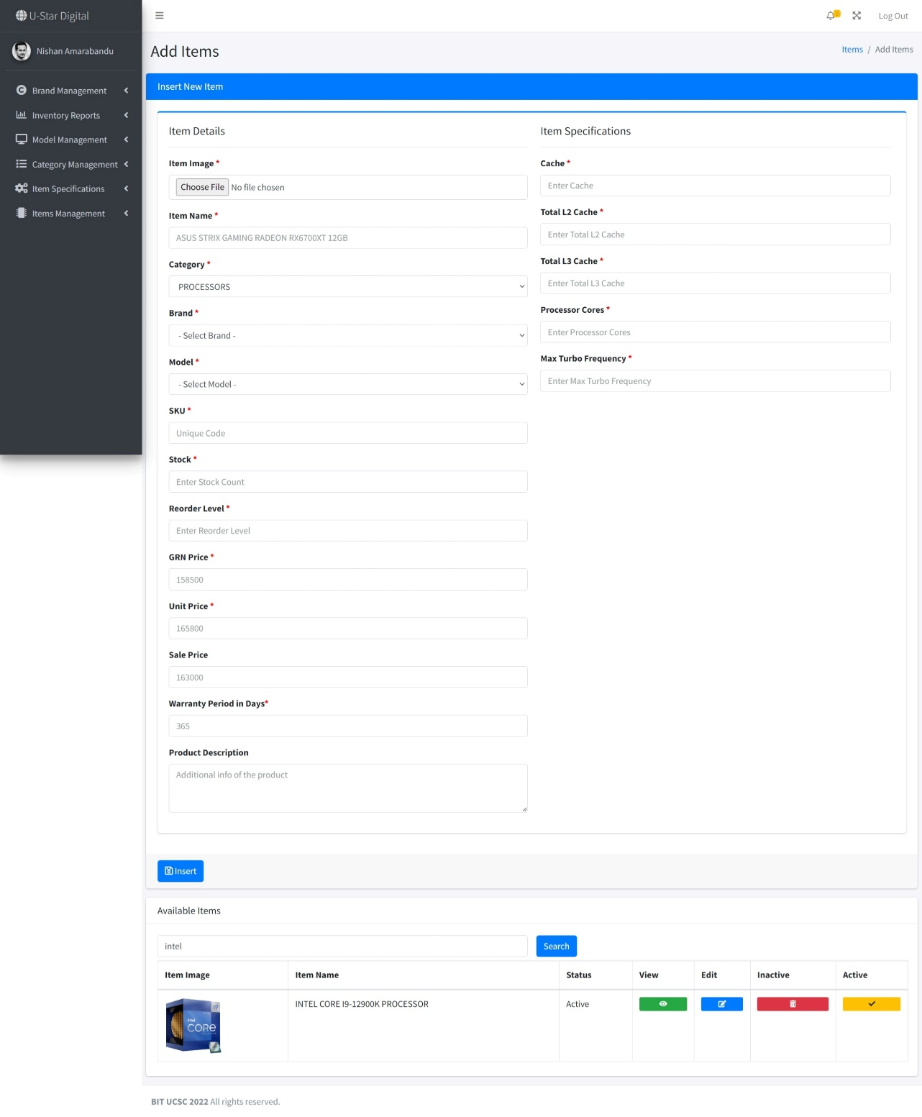

Figure 3. 8: Add Items form

# Chapter 4 – Implementation

## 4.1 – Chapter Introduction

In comparison to the previously described analysis and design of the system, implementation was the phase in which U-Star Digital carried out the developing and real-world testing of the Web-Based Computer Hardware Purchasing and Troubleshooting Assistant Management System. In order to maintain the system's quality and security, best practices were followed during implementation and development.

## 4.2 – Implementation Environment

There are two primary implementation environments for a system when it comes to implementation. There are two types of implementation environments: software and hardware. To keep implementation and maintenance costs low, it was mostly done with free and open-source software and tools. The tools and procedures utilized in this phase are listed below.

4.2.1 – Software EnvironmentThe work is done on a computer that runs the Microsoft Windows operating system. As a result, a software environment that is compatible with Windows was established. The XAMPP server was utilized because it comes with Apache, MySQL, and PHP on Windows. Visual Studio Code IDE has been used as the primary design tool for development. An open-source integrated development environment (IDE) for programming languages including  Java, PHP, C++, and others is called Visual Studio Code. The most recent iteration of the most well-liked HTML, CSS, and JavaScript framework for building responsive, mobile-first websites is called Bootstrap 5.

Although PHP is the primary development language, it is supported by several other languages.

* HTML – to create the web pages' content
* JavaScript – for content validation and filtering
* CSS – to make the web pages styles
* JQuery – Code libraries that can be reused
* Ajax – to make changes to the content without having to reload the page
* diagrams.net – to sketch a design diagram
* GanttPRO – to create a project timeline
* Microsoft Word – to compose a documents

### 4.2.2 – Hardware Environment

The computer used to build this system has the properties portrayed in Figure 4.1.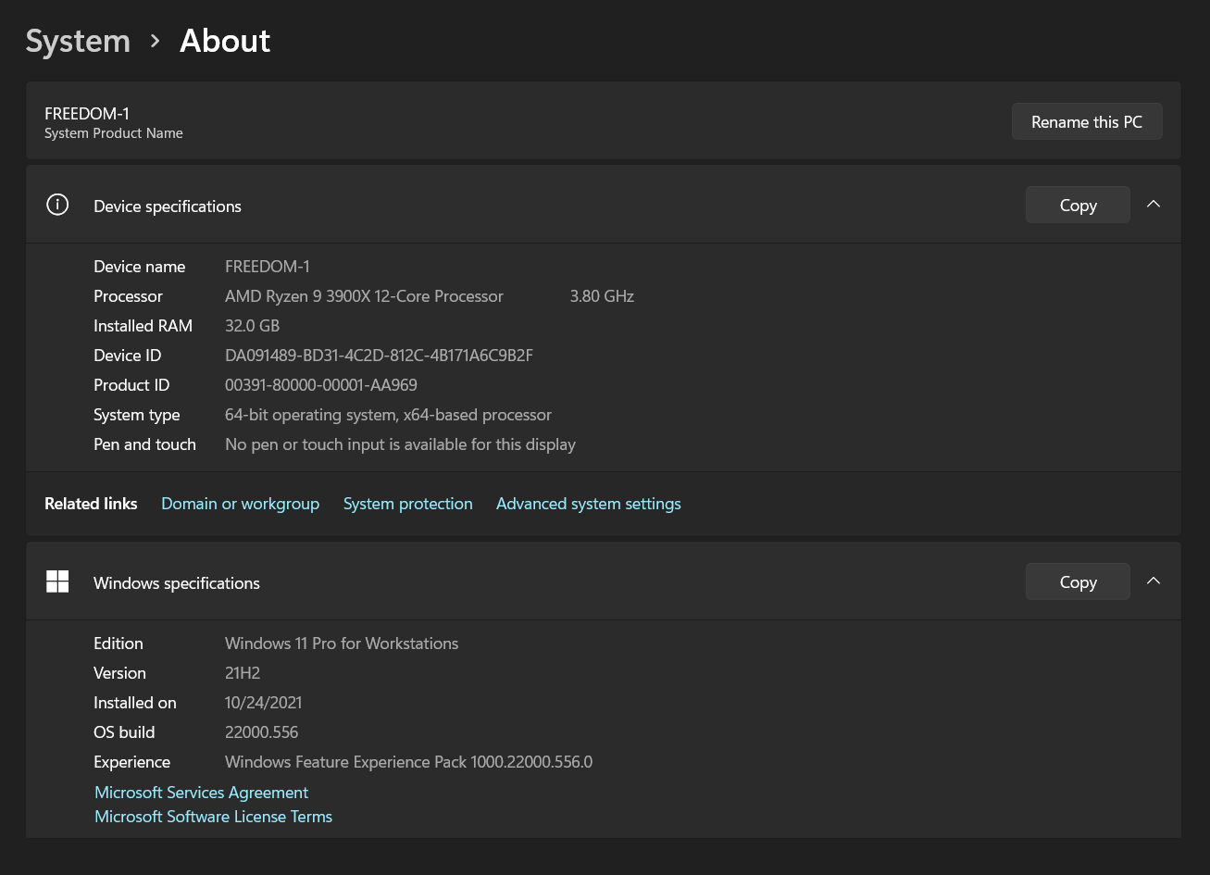

Figure 4. 1: Hardware Environment

4.2.3 – Other Software and Development ToolsWas used authoring tools such as Adobe Photoshop CC for designing graphics and web browsers such as Firefox, Google Chrome, and Internet Explorer for testing the system, in addition to software development tools.

## 4.3 – Justification for the choice of the implementation platform

* **Web Server**

The project's dedicated server, XAMPP Server, was utilized to manage the application using phpMyAdmin. The web server was handled by Apache, which is another part of its solution stack. It helps to get server side language to execute smoothly.

* **Database Server**

The software's database server was MySQL, which is also part of the XAMPP solution stack. MySQL is a relational database management system that is help to manage system database and database queries

* **PHP**

PHP is used as the entire project backend language. It supports implementing the business logic onto the project and make project more dynamic with user inputs.

* **HTML**

As a web-based project, HTML is more pertinent. It served as the front-end markup language for the project. It was useful for controlling how users may view information.

* **CSS**CSS was used to style the system. It enhances the project's visual appeal and improves the UX and informational value of specific elements.
* **Bootstrap 5**

To make the system more responsive, Bootstrap 5 was employed. It improved the effectiveness of front-end development.

* **JavaScript**

The front-end user experience was dynamically created using Javascript. It lessened the burden on the project's web application server and assisted in making better use of the web server's resources.

* **JQuery**In the project's front-end to back-end communication, JQuery is utilized to call ajax methods. It shortened the coding process.
* **Microsoft Word**Documentation for the project was created using Microsoft Word.
* **Adobe Photoshop CC**More assistance was given for modifying the photographs with Adobe Photoshop CC.

4.3.1 System File StructureThe file structure of the created system is presented 4.2.

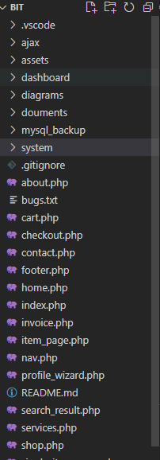

Figure 4. 2: File Structure

## 4.4 – High Level Module Structure

Inventory Management Module – Accessed by Inventory Manager  
Delivery Management Module – Accessed by Delivery Manager  
Report Management Module – Accessed by Shop Manager  
Troubleshooting Assistant Module – Accessed by Technician  
User Management Module – Accessed by Administrator

4.5 – Major Code Segments4.5.1 – Customer Registration Code Segments

* Member Registration Form

Customers are registered for the system using the member registration code segment in Figure 4.3. Both checkout.php and myaccount.php make use of it.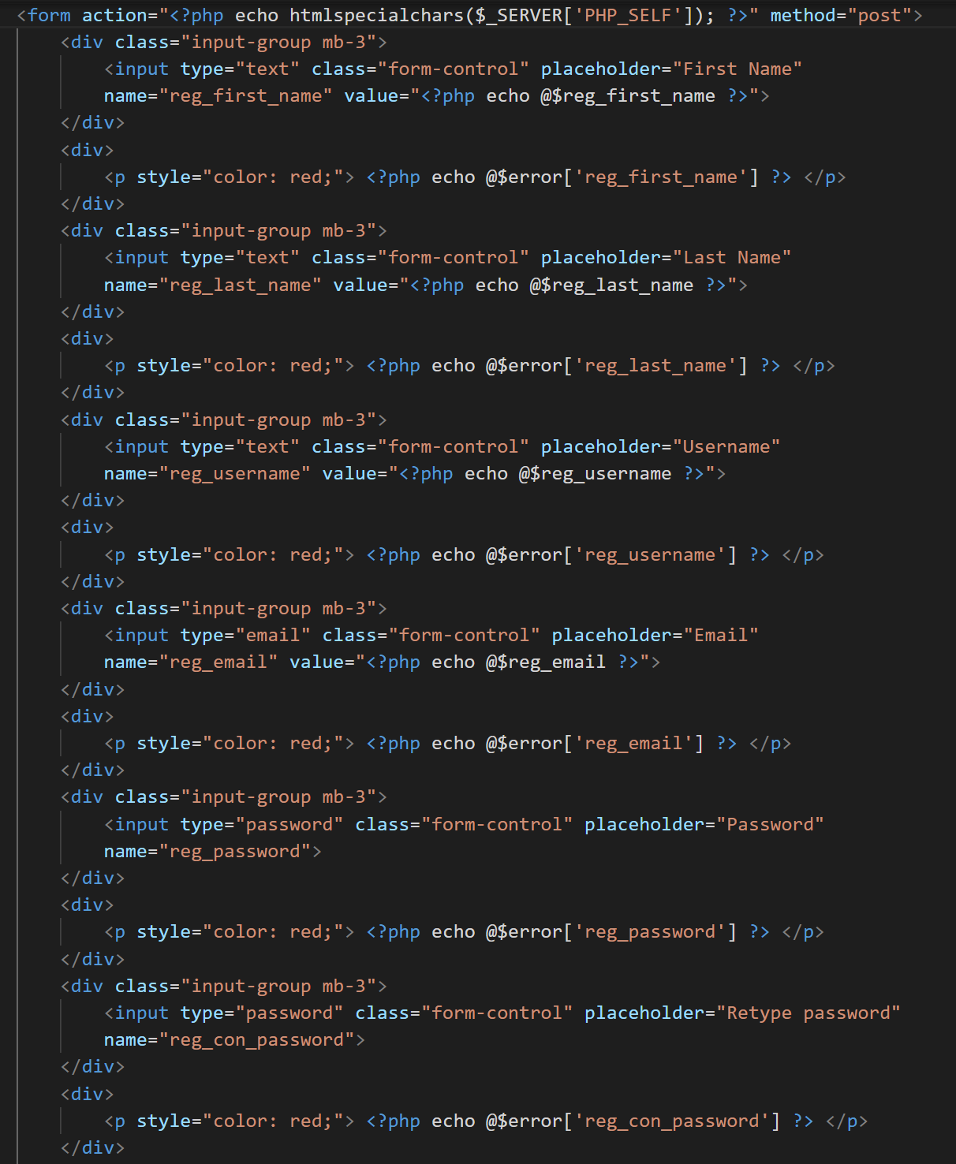

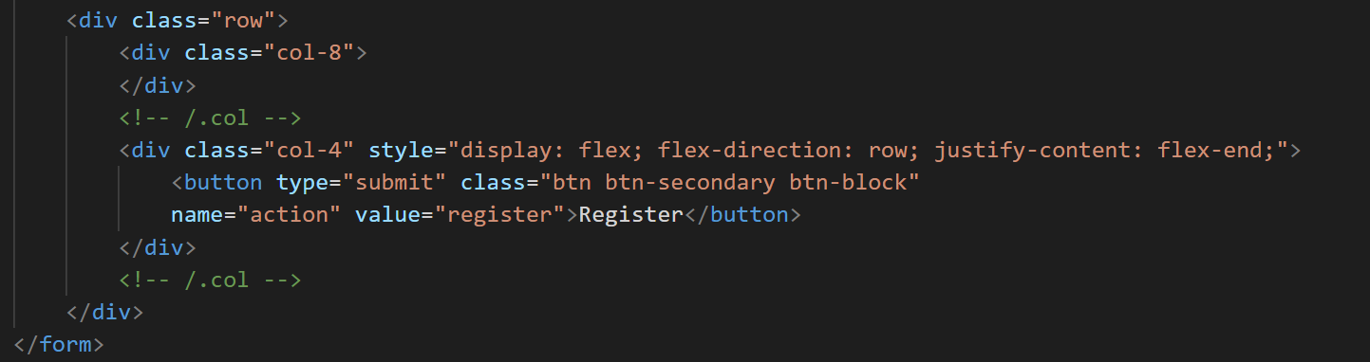

Figure 4. 3 Member Registration Code Segments

* Basic Validation of Customer Registration Form

The basic validation of the customer registration form code segment shown in figure 4.4 is used to check user input before allowing unauthorized data to be entered into the database.

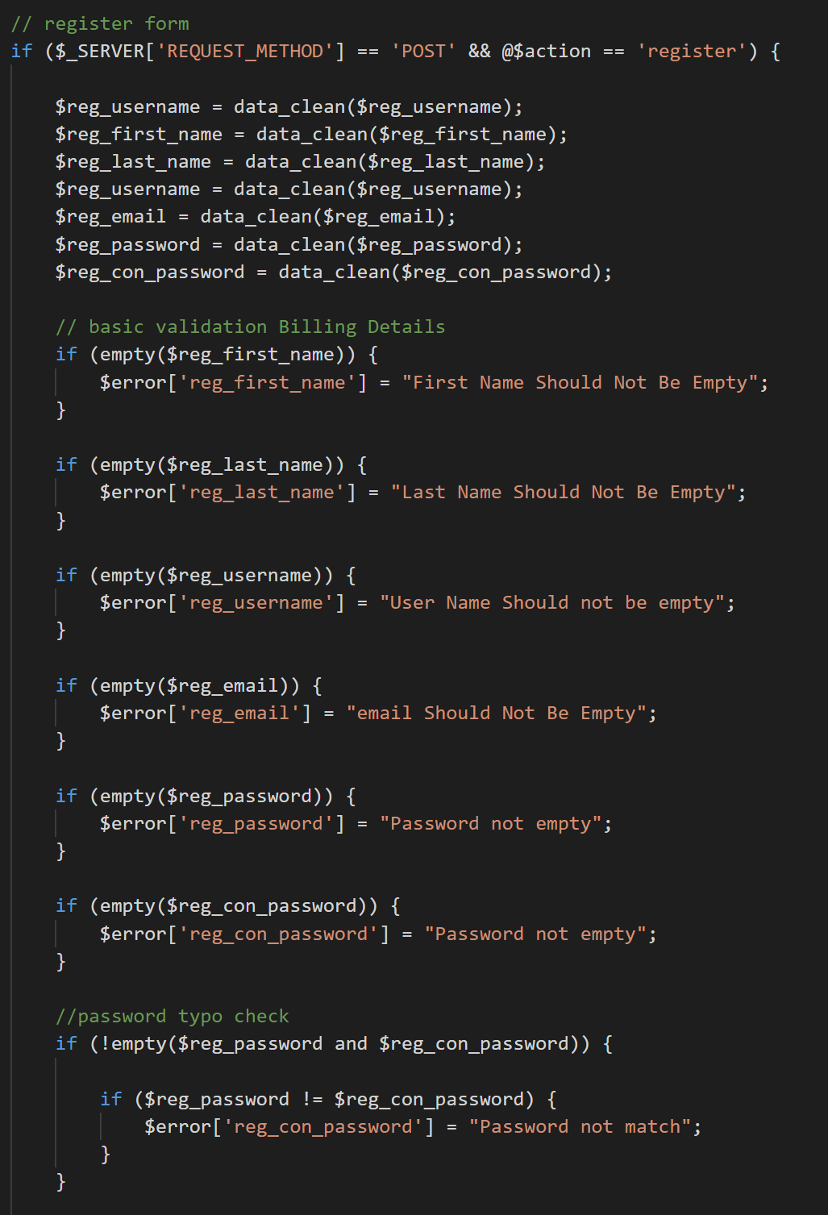

Figure 4. 4 Basic Validation Code Segment

* Advance Validation of Customer Registration Form

Figure 4.5 Advanced validation of customer registration form code segment is used to validate the user input and prevent entering unwanted data into the database.

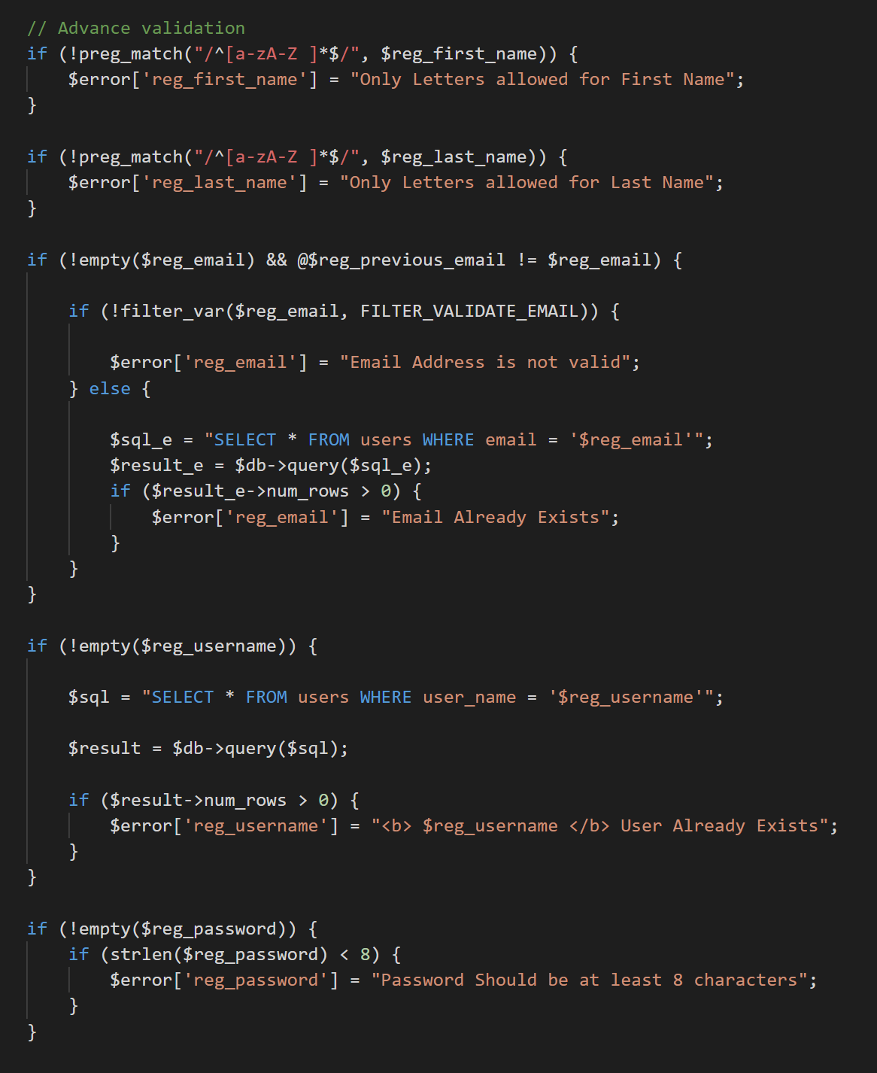

Figure 4. 5 Advanced Validation Code Segment

### 4.5.1 – Customer Checkout Code Segments

When customers add an item to their cart, the following customer checkout code segment is utilized for the checkout process, as shown in figure 4.6.

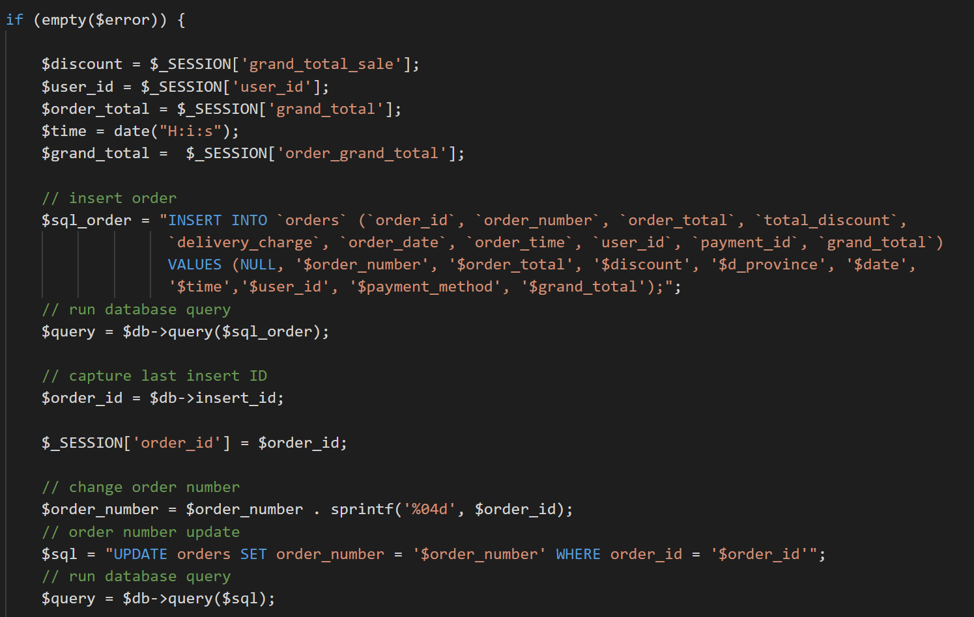

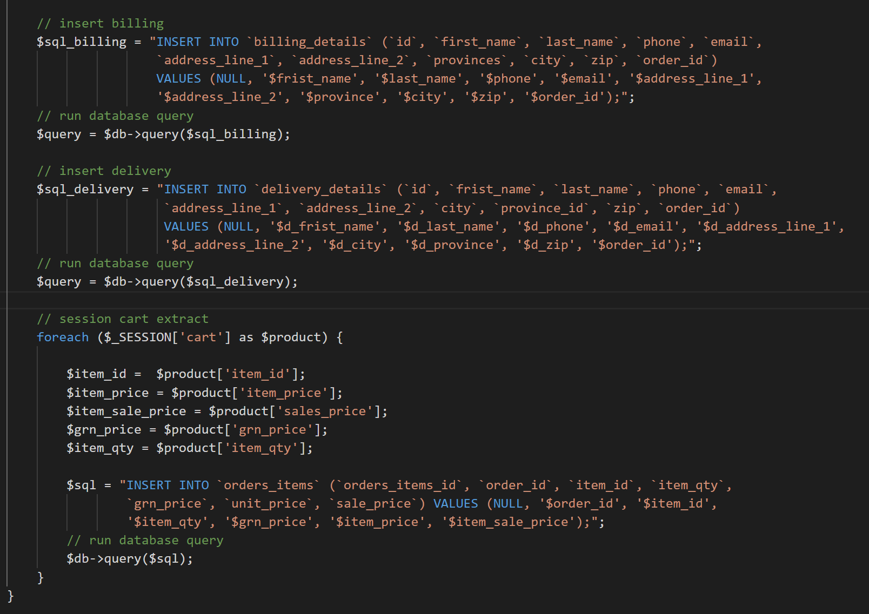

Figure 4. 6 Customer Checkout Code Segment

## 4.6 – Reused Existing Codes

When implementing the system, several of the well-tested re-usable components were added in order to maximize efficiency and provide more interest to the system.

* **Reusable CSS Files**

Figure 4.7 shows how the complete system's front-end styling is done using CSS codes.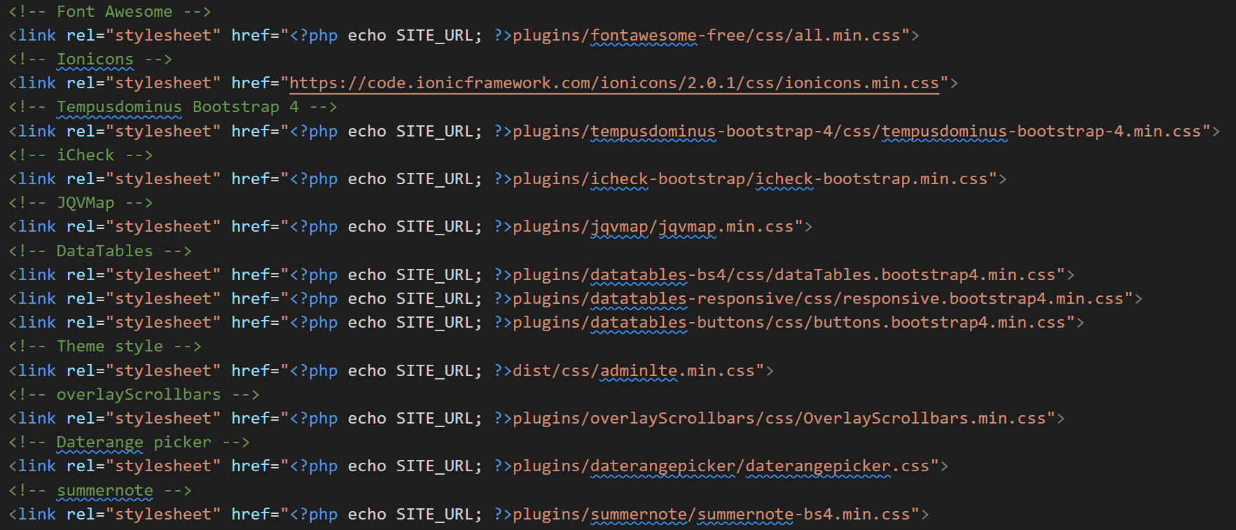

Figure 4. 7 Reusable CSS Files

* **Reusable JavaScript Files**

The reusable javascript code used to make the system’s front-end dynamic is shown in Figure 4.8.

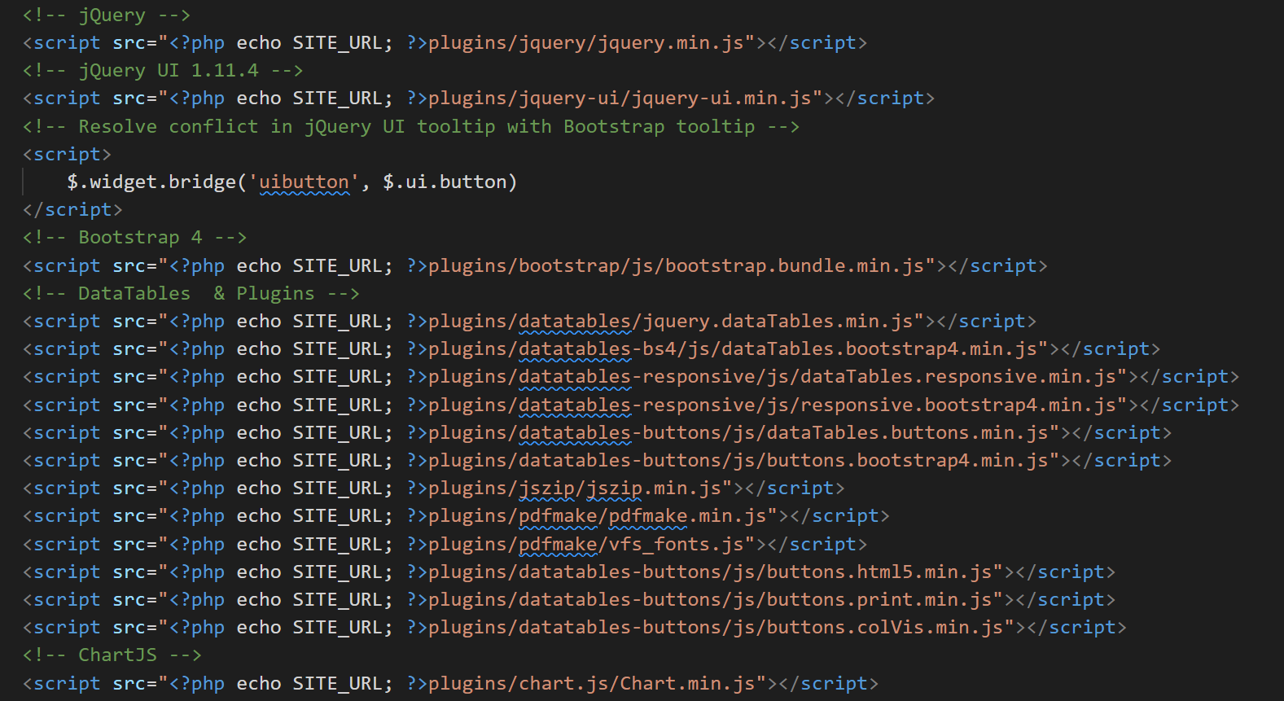

Figure 4. 8 Reusable Javascript files

* **Reusable Image Upload Function**

Figure 4.9 shows how to upload images to the entire system using the reusable image upload function.

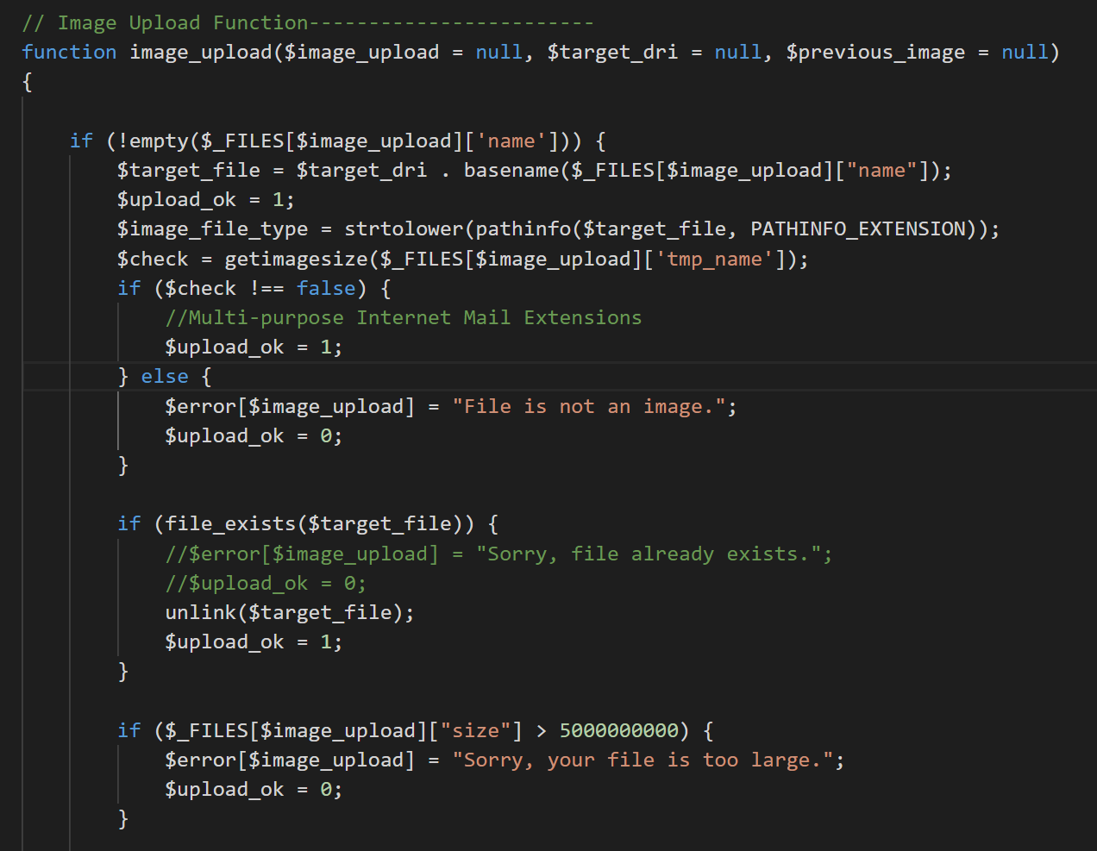

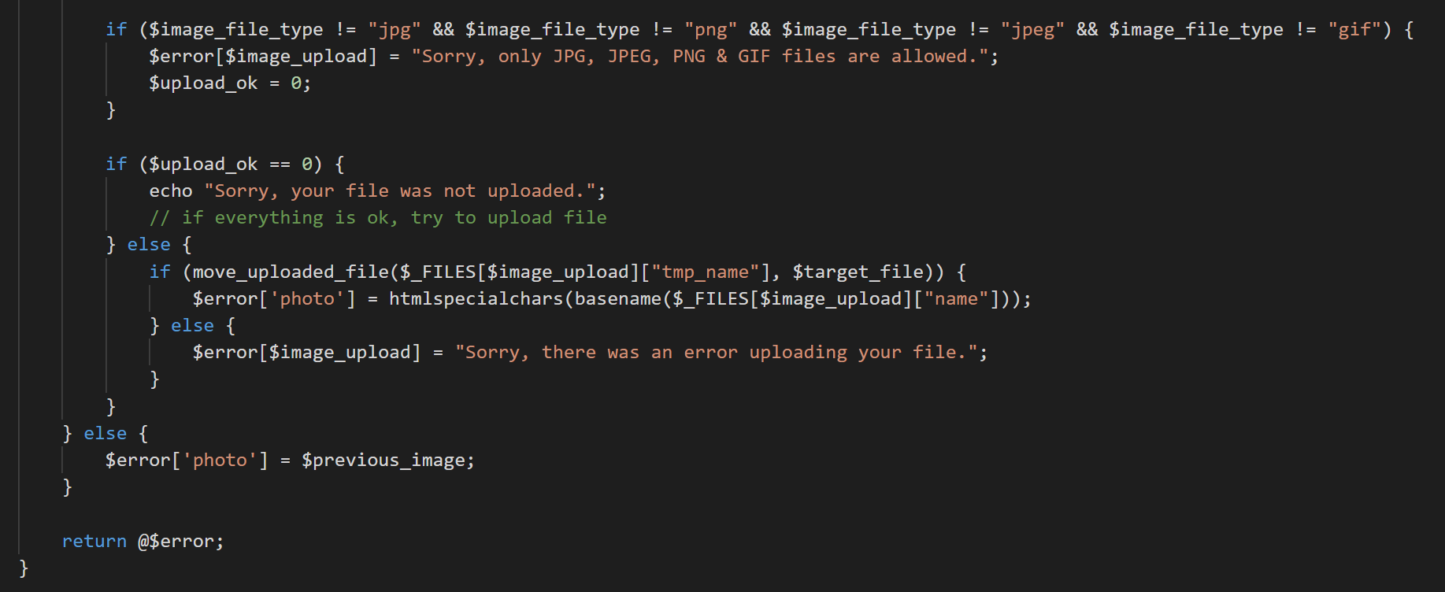

Figure 4. 9 Reusable Image Upload Function

* **Reusable Data Clean Function**

The reusable data clean function in figure 4.10 is used to clean user inputs to prevent input the unwanted charters.

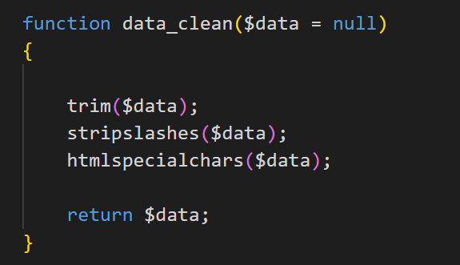

Figure 4. 10 Reusable Data Clean Function

* **Reusable Main Menus Code in the Dashboard**

In figure 4.11 code segment is used to dynamic the main menu for the muli-level user inputs.

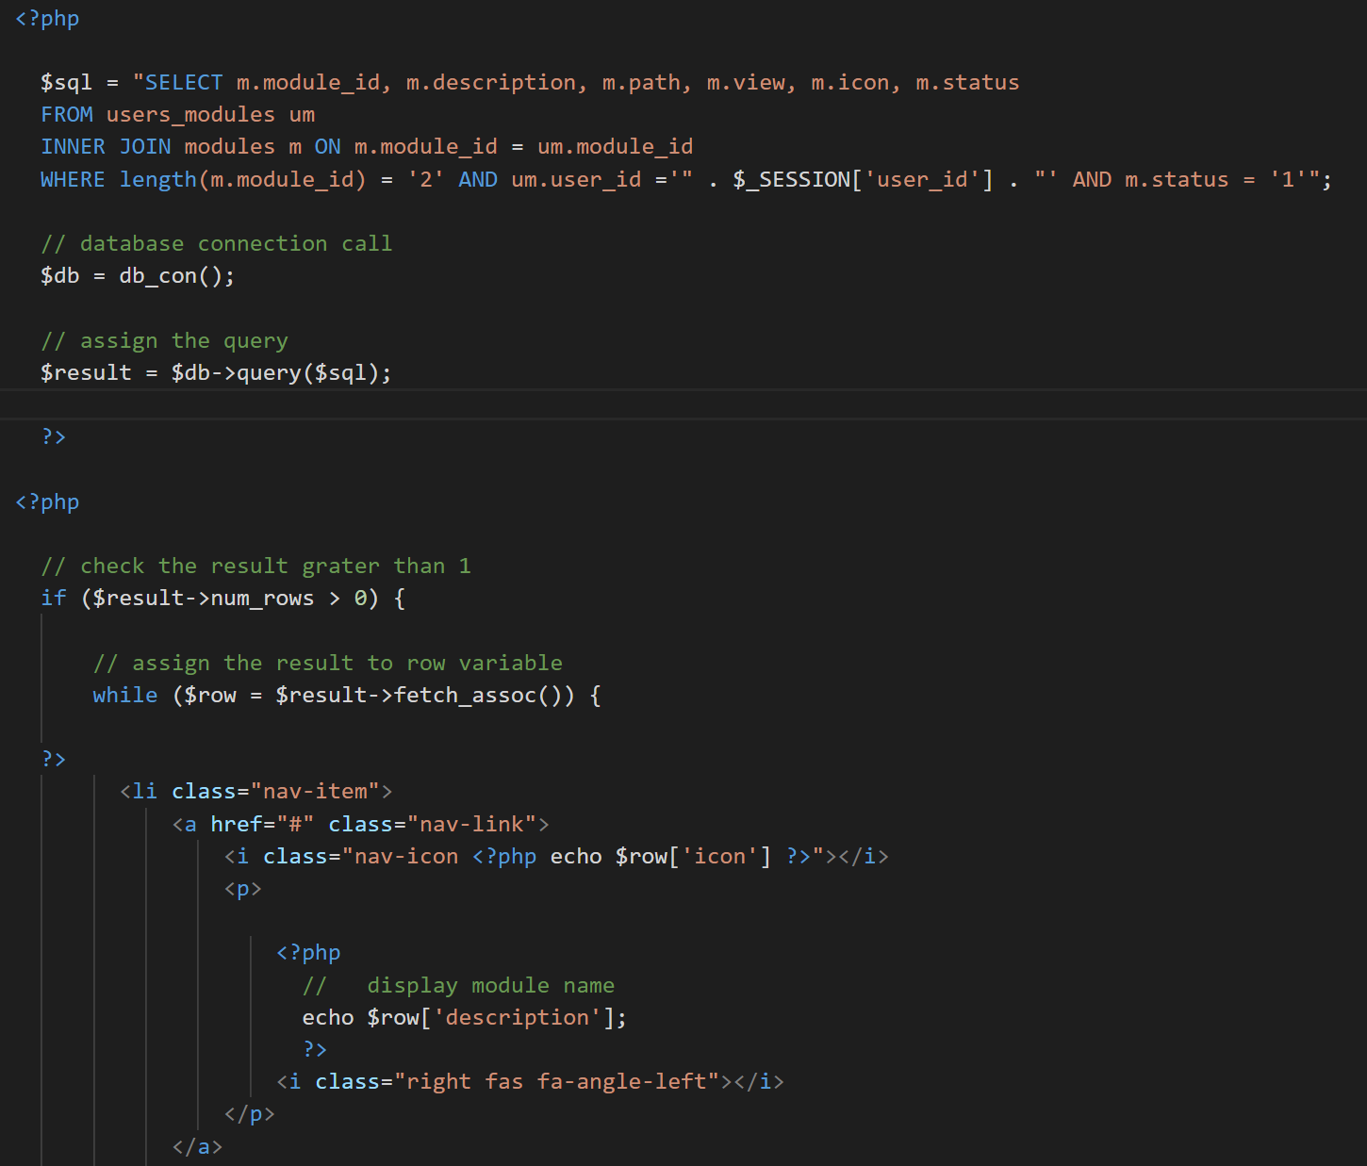

Figure 4. 11 Reusable Main Menu Code Segment

* **Reusable Sub Menus Code in the Dashboard**

In figure 4.12 code segment is used to dynamic for the sub menus.

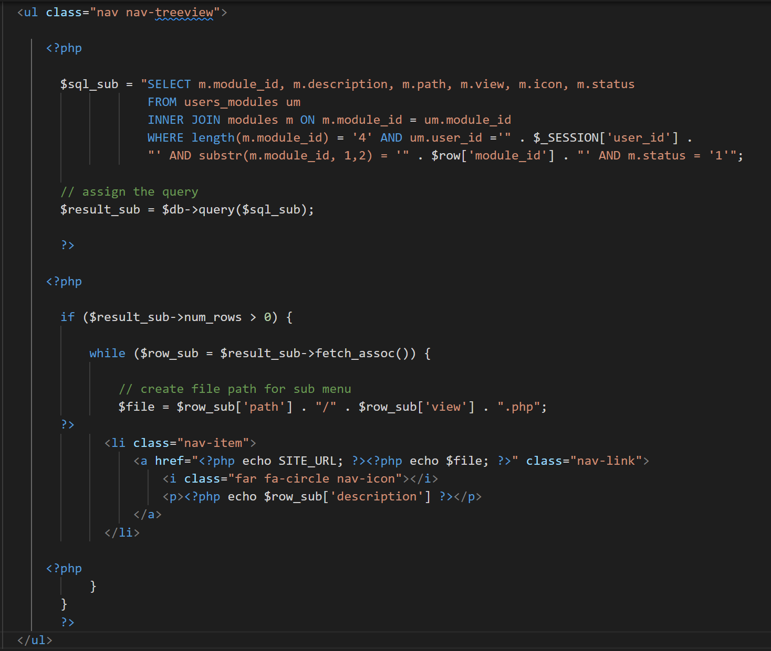

Figure 4. 12 Reusable Sub Menu Code Segments

# Chapter 5 – Evaluation

## 5.1 – Introduction

The Evaluation chapter includes descriptions of the test strategy, test outcomes, and user evaluation. To check and verify the system's performance, a wide range of data should be confirmed. During this step, the system's feature is assessed. The program is put through its paces in accordance with the test strategy.

## 5.2 - Description of testing approach

“A test approach is the test strategy implementation of a project, defines how testing would be carried out. Test approach has two techniques:

**Proactive** - An approach in which the test design process is initiated as early as possible in order to find and fix the defects before the build is created.

**Reactive** - An approach in which the testing is not started until after design and coding are completed.

There are many strategies that a project can adopt depending on the context and some of them are:

- Dynamic and heuristic approaches   
- Consultative approaches   
- Model-based approach that uses statistical information about failure rates.   
- Approaches based on risk-based testing where the entire development takes place based on the risk   
- Methodical approach, which is based on failures.   
- Standard-compliant approach specified by industry-specific standards.” [6]

## 5.3 - Test strategy

“A Software Test Plan is a document describing the testing scope and activities. It is the basis for formally testing any software/product in a project. It describes the scope, approach, resources and schedule of intended test activities. It identifies amongst others test items, the features to be tested, the testing tasks, who will do each task, degree of tester independence, the test environment, the test design techniques and entry and exit criteria to be used, and the rationale for their choice, and any risks requiring contingency planning. It is a record of the test planning process.” [7]

### 5.3.1 - Verification and Validation

“Verification and Validation is the process of investigating that a software system satisfies specifications and standards and it fulfills the required purpose. Barry Boehm described verification and validation as the following:

**Verification:** Are we building the product right?

**Validation:** Are we building the right product?

Verification is the process of checking that a software achieves its goal without any bugs. It is the process to ensure whether the product that is developed is right or not. It verifies whether the developed product fulfills the requirements that we have. Validation is the process of checking whether the software product is up to the mark or in other words product has high level requirements. It is the process of checking the validation of product i.e. it checks what we are developing is the right product. it is validation of actual and expected product.” [8]

### 5.3.2 - Testing Process

1. **Unit testing**

Unit testing, a type of software testing, involves testing individual programme units or components. Verifying that each piece of software operates as intended is the goal. The smallest bit of testable software is called a unit.

1. **Integration Testing**

Following unit testing, integration testing is carried out, in which many units are combined and tested as a whole. The purpose of this testing level is to highlight issues with integrated component interfaces and interactions. Depending on the definition of a unit, either white-box or black-box testing can be used.

1. **System Testing**

System testing is a sort of testing used to determine whether an integrated system as a whole satisfies the requirements. The black box testing approach is used to test the system's functionality from end to end during system testing.

1. **Acceptance Testing**

Before the system was put into service, this was the last phase of testing. The system was tested using data supplied by the system procurer rather than fictitious test data. This is a beta test of the product carried out by actual customers.

1. **Regression Testing**

Regression test is a testing of software testing used to make sure that present functionalities haven't been broken by a recent programme or code revision. This testing's main objective is to make that the system's current functional and non-functional features haven't been negatively impacted by the most recent updates.

5.4 - Proof of testing of work

The most significant component of this phase is creating test scenarios. Test cases that are well-planned should be able to validate system module functionality. System test cases must validate every type of system need. The essential components of the test cases built for this system are listed below.

* **Test case for Customer Registration**

The following major test cases ran in the system (Table 5.1)

|  |  |  |  |
| --- | --- | --- | --- |
| **Test No** | **Test Case** | **Expected Result** | **Status** |
| 1 | Submit the form without filling in the mandatory fields. | Prevent submitting and show error messages | Pass |
| 2 | Use already exists username and email address | show error message | Pass |
| 3 | Invalid email insert | show error message | Pass |
| 4 | Incorrect Password length insert | show error message | Pass |
| 6 | Invalid phone number insert | show error message | Pass |
| 7 | Enter the numbers in the text fields | show error message | Pass |
| 8 | Invalid zip inserts | show error message | Pass |
| 9 | Submit the form with the correct data | Redirect to the login page | Pass |
| 10 | Without login URL browsing to the customer dashboard | Redirect to login page | Pass |

Table 5. 1: Test Case for Customer Registration

* **Test case for Customer Login**

The system underwent the key test cases listed below. (Table 5.2)

|  |  |  |  |
| --- | --- | --- | --- |
| **Test No** | **Test Case** | **Expected Result** | **Status** |
| 1 | Enter a valid username and password | Successful login to the system | Pass |
| 2 | Enter username only | show error message | Pass |
| 3 | Enter only password | show error message | Pass |
| 4 | Enter invalid username and password | show error message | Pass |

Table 5. 2: Test Results for Customer login

* **Test case for Checkout Process**

Checkout process test cases (Table 5.3).

|  |  |  |  |
| --- | --- | --- | --- |
| **Test No** | **Test Case** | **Expected Result** | **Status** |
| 1 | Submit the form without filling in the mandatory fields. | Prevent submitting and show error messages | Pass |
| 2 | Enter the numbers in the text fields | show error message | Pass |
| 3 | Invalid email insert | show error message | Pass |
| 4 | Invalid phone number insert | show error message | Pass |
| 5 | Invalid zip inserts | show error message | Pass |
| 6 | Without check the delivery check box | Show error message of delivery form | Pass |
| 7 | Without selecting the payment method | Show error message | Pass |
| 8 | Change the delivery value related to the province | Show delivery charges and calculate to total | Pass |
| 9 | Submit the form with the correct data | direct to the invoice page | Pass |
| 10 | Without login URL browsing to the checkout and invoice | Redirect to the cart page | Pass |

Table 5. 3: Test Result for Checkout Process

## 5.5 - User Acceptance Testing

“User Acceptance Testing (UAT), also known as beta or end-user testing, is defined as testing the software by the user or client to determine whether it can be accepted or not. This is the final testing performed once the functional, system, and regression testing are completed.

The main purpose of this testing is to validate the software against the business requirements. This validation is carried out by the end-users who are familiar with the business requirements.

UAT, alpha, and beta testing are different types of acceptance testing.

As the user acceptance test is the last testing that is carried out before the software goes live, obviously this is the last chance for the customer to test the software and measure if it is fit for the purpose.” [9]

## 5.6 - User Evaluation

An evaluation that includes people for whom the system has suggested users is referred to as a user evaluation because it is based on user input. Examples of user evaluation techniques include probable methods, observational methods, questionnaires, interviews, and physiological monitoring techniques. Users of various types and access levels were chosen to be part of the sample, and user evaluation surveys were given out to collect feedback.

Figure 5.1 depicts an example evaluation questionnaire for testing user satisfaction, figure 5.2 depicts a user acceptance test evaluation sample, and figure 5.3 depicts the system's user feedback results analysis diagram.

|  |  |  |  |  |  |  |  |  |  |  |  |  |  |  |  |  |  |  |  |  |  |  |  |  |  |  |  |  |  |  |  |  |  |  |  |  |  |  |  |  |  |  |  |  |  |  |  |  |  |  |  |  |  |  |  |
| --- | --- | --- | --- | --- | --- | --- | --- | --- | --- | --- | --- | --- | --- | --- | --- | --- | --- | --- | --- | --- | --- | --- | --- | --- | --- | --- | --- | --- | --- | --- | --- | --- | --- | --- | --- | --- | --- | --- | --- | --- | --- | --- | --- | --- | --- | --- | --- | --- | --- | --- | --- | --- | --- | --- | --- |
| **User Feedback Form – Computer Hardware Purchasing and Troubleshooting Assistant Management System for U-Star Digital**  Role of User: …………………………………...  Test Date: ………………………………………  Mark (✔) inside the box. Please provide a more comprehensive response with your honest option.   |  |  |  |  |  | | --- | --- | --- | --- | --- | | No | Description | Exceptional | Satisfied | Bad | | 1 | User interface design |  |  |  | | 2 | system's response time |  |  |  | | 3 | Form validation |  |  |  | | 4 | Understandability of error messages |  |  |  | | 5 | Interaction with navigation links and buttons |  |  |  | | 6 | system's responsiveness |  |  |  | | 7 | Report generating capability |  |  |  | | 8 | Recognizing the system's design |  |  |  | | 9 | Efficiency of the functionalities |  |  |  | | 10 | Overall impressions of the system |  |  |  |   Thank You |

Figure 5. 1: User Feedback Form

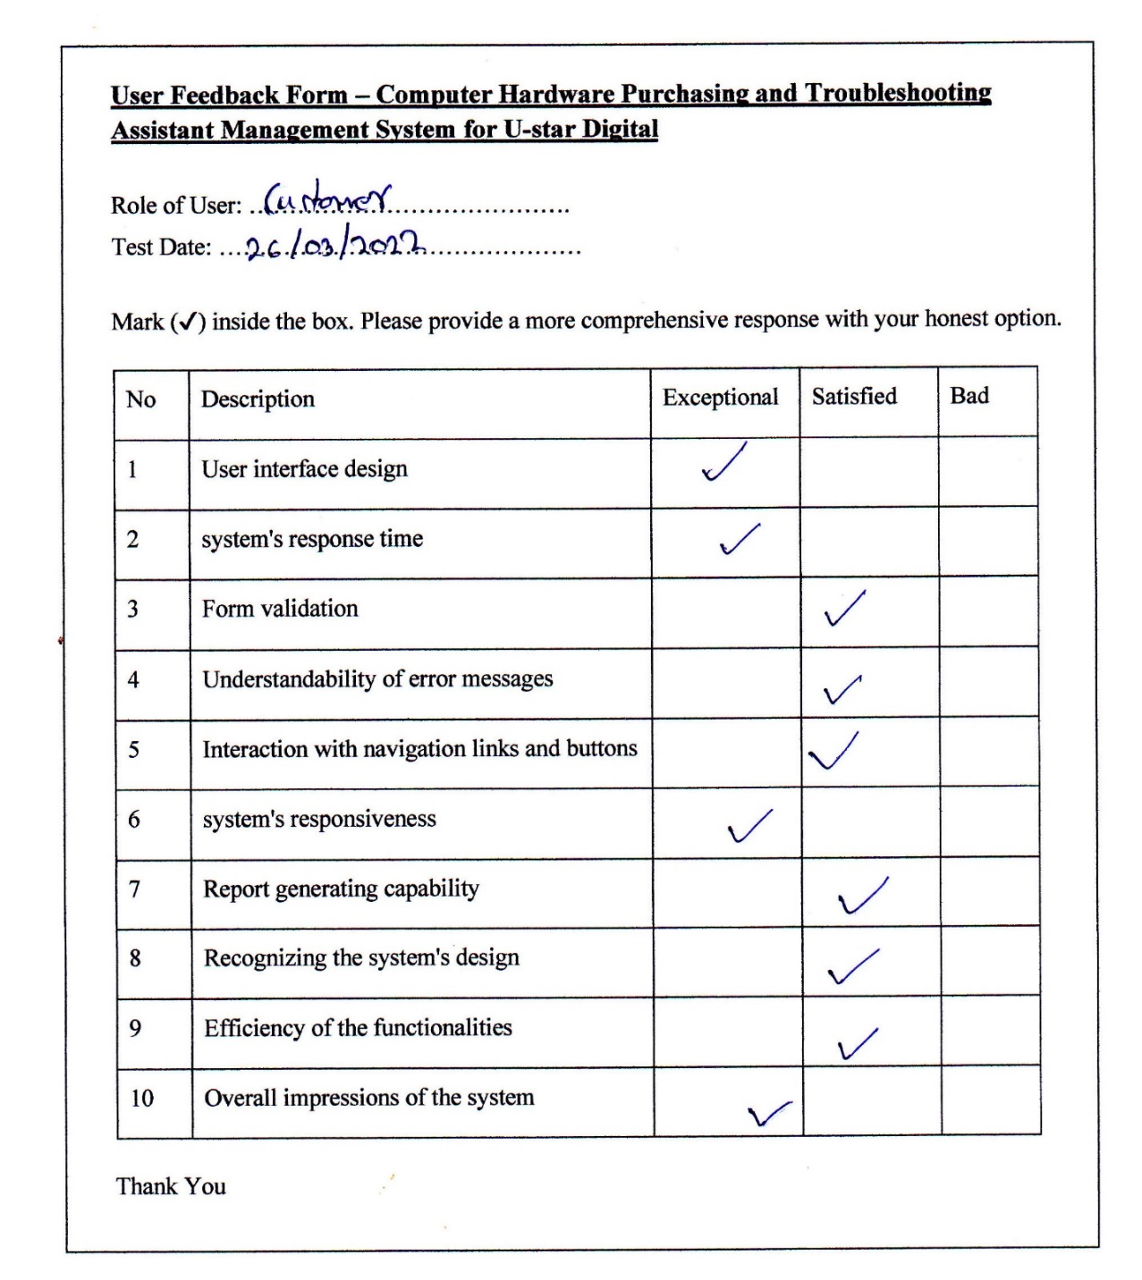

Figure 5. 2: User Acceptance Test Evaluation Sample

Figure 5. 3: Summary of User Feedback Evaluation

# Chapter 6 – Conclusion

## 6.1- Introduction

This chapter highlights the lessons learned while working on the U-Star Digital project to design a Computer Hardware Purchasing and Troubleshooting Assistant Management System. It also makes suggestions for future improvements to the system's performance and usability.

## 6.2 - Critical evaluation of the project

U-Star Digital currently does not have a system in place to link its shopping operations. To capture client information, their employees use spreadsheet programs and manual (paper papers). There is less integrity, the workload for the staff and their clients is high, inaccurate data levels occur, and all procedures are highly slow, time-consuming, and difficult to manage due to the use of paper documents and spreadsheets for data recording and data analysis.

The proposed solution was created to address those flaws while also improving their entire business process. The system was created with the most up-to-date development standards and technology in mind, as well as the requirement to expand and improve the business and the system in the future.

The client's criteria were helping the project become doable. Since the documentation's stated scope was functional and some client criteria weren't quite met, Examples include email notifications for the order process, user dashboard notifications for delivery updates, and so on. Test results indicate the system's user behaviour. The outcomes can help establish whether the system is suitable for real-time implementation.

Finally, the client provided feedback that was deemed acceptable for phase one and required further explanation of the features specified in the system as well as the use of a validation procedure to address some issues.

## 6.3 - Lesson learned

This project was the first time I had worked on a real-world project. As a student who took on this project, this software development has provided me with a wealth of programming expertise. During the system's implementation, the programming skills learned in the previous semesters were put to use in a real-world setting.

As a student may have many queries about the front end, back end, and databases when working on this kind of project. In the pressing time period, searching the internet for the ideal solution is considerably more challenging.

Front end HTML and CSS work is manageable, but Javascript and jQuery have problems obtaining some data when used with ajax functions. Utilizing a variety of new PHP functions, further validation strategies were discovered in the back end to increase system security.

Working on a project allowed me to obtain and improve soft skills including communication, creative thinking, logical thinking, decision making, positivism, motivation, problem-solving, understandability, writing skills, self-learning, researching skills, self-confidence, and so on.

## 6.4 - Future work

The intended software is now accessible and completely functional, allowing the customer to manage and afterwards carry out the entire operation in a far better, more precise, and error-free manner. The following is the project's future scope.

* **Website Mobile Responsiveness**

The system's current state is only visually appealing for desktop computers. We intend to change the website's responsiveness so that users of mobile devices and tablets can access it more comfortably.

* **Creating a Mobile Application**

Users will be able to access and use the system more readily on their mobile devices thanks to the development of an interactive mobile application for this system.

* **Integrating the Internet payment gateway**

Customers are allowed to make payments more readily if they have access to an internet payment gateway.

* **AI Base Troubleshooting Assistant**

Implementing an artificial intelligence-based troubleshooting assistant that crawls the database and answers to provide the best response for the specified inquiry.

* **Computer Hardware Assistant**

Implimenting this module assists customers who are unfamiliar with computer hardware. It takes all the details of individual items and matches them with the next most appropriate piece, and completes the assembly of an entire computer. After completing, customers have an option to check out the selected parts and make a payment to complete the assistant process.

# References

[1] Micro Center, “About Micro Center”, <https://www.microcenter.com/>, [Online].

Available: <https://www.microcenter.com/site/content/about_microcenter.aspx>

[Accessed: 18.12.2021].

[2] newegg, “About Newegg corporate site”, <https://www.newegg.com/>, [Online].

Available: <https://www.newegg.com/corporate/about>

[Accessed: 18.12.2021].

[3] T. Alspaugh, “Software Process Models”, [www.thomasalspaugh.org](http://www.thomasalspaugh.org), [Online].

Available: <https://www.thomasalspaugh.org/pub/fnd/softwareProcess.html#scrum>

[Accessed: 22.01.2022].

[4] Agile Alliance, “What is extreme programming”, <https://www.agilealliance.org/> [Online]. Available: <https://www.agilealliance.org/glossary/xp>

[Accessed: 22.01.2022].

[5] Techterms.com, “RUP (Rational Unified Process) Definition”, <https://techterms.com/> [Online]. Available: <https://techterms.com/definition/rup>

[Accessed: 22.01.2022].

[6] “Test Approach Description”, https://www.tutorialspoint.com/ [Online].

Available:<https://www.tutorialspoint.com/software_testing_dictionary/test_approach.htm>

[Accessed: 18.02.2022].

[7] Test plan, in software testing fundamentals, “Test Plan”, [Online]. Available: <https://softwaretestingfundamentals.com/test-plan>

[Accessed: 19.02.2022].

[8] “Software Engineering | Verification and Validation”, [Online]. Available: <https://www.geeksforgeeks.org/software-engineering-verification-and-validation/>

[Accessed: 19.02.2022].

[9] A Complete Guide, “User Acceptance Testing”, www.softwaretestinghelp.com [Online]. Available: https://www.softwaretestinghelp.com/what-is-user-acceptance-testing-uat/

[Accessed: 20.02.2022].

# Appendix A – System Manual

The correct way to install, set up, configure, and operate the system for U-Star Digital is described in detail in this manual.

**Step 01**

The following is a list of the hardware and software requirements as shown in tables A.1 and A.2.

**Hardware Requirements**

|  |  |
| --- | --- |
| **Hardware** | **Requirements** |
| Processor | Intel(R) Core(TM) i3-5005U CPU @ 2.00GHz |
| Memory | 2GB or Above |
| Storage | 25GB |
| Display | 1366 x 768 Resolution Monitor |
| Internet | 4 Mbps internet connection |

Table A. 1: Hardware Requirements

**Software Requirements**

|  |  |
| --- | --- |
| **Hardware** | **Requirements** |
| Operating System | Microsoft Windows 7 or Above Operating System |
| Web Server | XAMPP release 7.3.33, 7.4.26 |
| Web Browser | Chromium-based web browsers / Firefox |
| Code Editor | Microsoft Visual Studio Code / Notepad++ |

Table A. 2: Software Requirements

**Step 02**

1. Downloading XAMPP Server
   1. WAMP Server can be downloaded and installed from the following URL. <https://www.apachefriends.org/download.html> (Figure A.1)
   2. Download the appropriate WAMP Server version.
   3. When installing WAMP Server on your computer, follow the instructions on the WAMP Server installation web page.

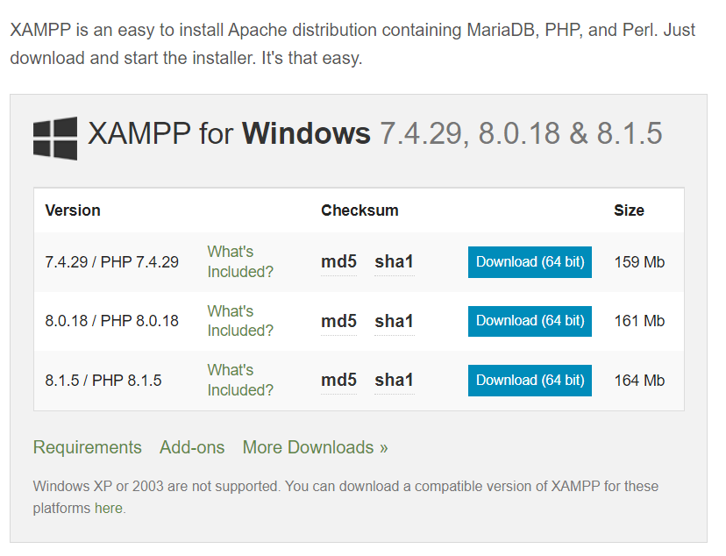

Figure A. 1: XAMMP Server Download Page

1. Installing XAMPP Server
   1. Run the XAMPP Server execution file that you downloaded (.exe).
   2. Deactivate UAC
   3. Choose a location to install the WAMP Server and proceed to install.
   4. Double-click on the XAMPP icon to launch the server. The server will then be started by clicking the start button.
   5. Start “Apache” and MySQL modules by clicking on the “Start” button.

**Step 03**

1. Create the Database
   1. Launch a web browser and enter <http://localhost/phpmyadmin>.
   2. If you want to set a password, log in to the database and enter a username "root" and password.
   3. Make a database with the specified name “db_ustar” (Figure A.2).

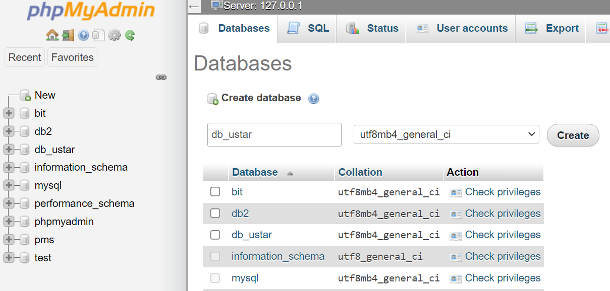

Figure A. 2: Create Database

1. Database File Import
   1. Choose a database that was generated and click the the “import” tab
   2. Navigate to the database folder on the CD and find the "db ustar.sql" file.
   3. Click the Go button.
2. Store the System File
   1. Go to the directory where the XAMPP server was set up.
   2. Find the "htdocs" directory.
   3. Copy the "u_star_system.zip" file from the given CD.
   4. Copy the file and paste it into the htdocs folder to unzip it.
3. Launching the System
   1. Type [http://localhost/ustar/](http://localhost/ustar/system/) to launch the system in your browser
   2. Type <http://localhost/ustar/system/> to login to the system in your browser.

# Appendix B – Design Documentation

The following diagrams represent a few other significant system functionalities, besides the charts for data modelling in Chapter 3 of the dissertation.

**Use Case Diagrams**

A use case diagram shows how a system's components relate to one another visually. A system analysis technique for locating, delineating, and arranging system needs is the use case. Based on their respective roles, the system's actors are organised into groups.

* **Use – Case Diagram for Customer Registration**

Both Figure B.1 and Table B.1 provide the use case narrative and use case diagram for customer registration, respectively.

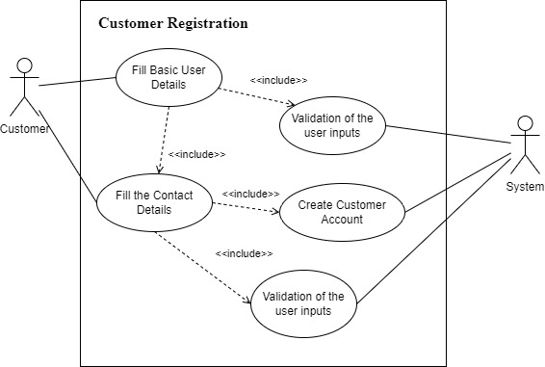

Figure B. 1: Use Case Diagram for Customer Registration

|  |  |  |
| --- | --- | --- |
| **Use-case Number** | UC-02 | |
| **Use-Case Name** | Customer Registration | |
| **Priority** | High | |
| **Actor** | Customer | |
| **Description** | The procedure for enrolling users with the system is described in this use case. | |
| **Precondition** | None | |
| **Post-condition** | The actor is directed to the customer login page to log in to the system if the use case was successful. | |
| **Basic course of Action** | **User Action** | **System Response** |
| 1. The Actor is registering as a customer on the My Account page.  3. The actor clicks the Register button after completing the form.  6. The Actor fills out the form and clicks the Done button. | 2. The form to enter user information is promoted by the system.  4. The system checks to make sure all the fields have been correctly completed and are legitimate.  5. All fields are valid system navigates to the complete profile page.  6. The system verifies that all the filled have been filled out and are valid.  7. System navigate to the My Account page to log in to the system.  8. Use case Exit |
| **Alternate course of Action** | 4.1 The system notifies the actor and then proceeds to step 3 of the basic course of action to request new information if all fields are not completed and have previously been claimed by another client.  5.1 The system notifies the actor and then proceeds to step 3 of the fundamental course of action to request new information if all fields are not completed and have previously been claimed by another client. | |

Table B. 1: Use Case Narrative for Customer Registration

* **Use – Case Diagram for Order Checkout**

Use case diagram for order checkout is given in Figure B.2 and use case narrative for order checkout is given in Table B.2.

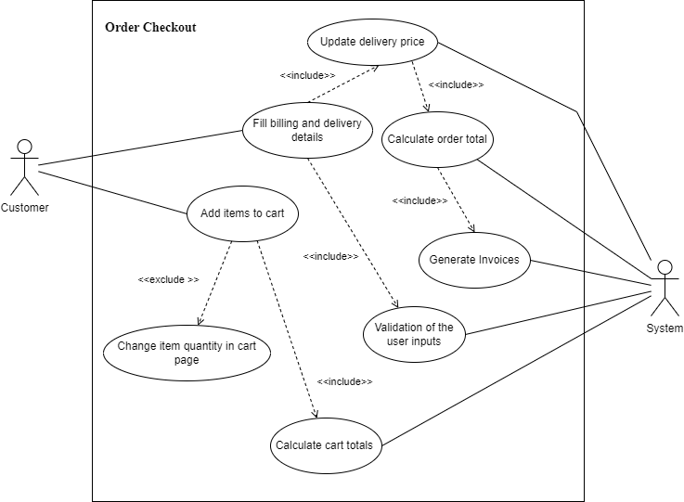

Figure B. 2: Use Case Diagram for Order Checkout

|  |  |  |
| --- | --- | --- |
| **Use-case Number** | UC-03 | |
| **Use-Case Name** | Order Checkout | |
| **Priority** | High | |
| **Actor** | Customer | |
| **Description** | This use case explains how to check out the things you've chosen from your shopping cart. | |
| **Precondition** | Need to add items to the cart | |
| **Post-condition** | When the process is completed successfully, the actor is directed to the invoicing page. | |
| **Basic course of Action** | **User Action** | **System Response** |
| 1. The Actor adds items to the cart.  2. Actor clicks cart icon in navigation.  5. The Actor clicks the checkout order button.  7. Actor fill the details of delivery and billing details forms and check the payment method and click the place your order button. | 3. System display all items added to the cart by the actor.  4. System calculates the item total price without delivery price.  6. System prompt billing details, delivery details forms, and payment methods.  8. System validates the actors input and redirects to the order invoice page. |
| **Alternate course of Action** | 5.1 If the Actor can change the cart item quantity, the system calculates the item total and cart total regarding to the item quantity.  5.2 If the Actor does not login to the system, the checkout page displays the login and register form  7.1 Actor needs to check the checkbox for delivery to the same billing address.  8.1 If the form is not validated properly system shows the error messages. | |

Table B. 2: Use Case Narrative for Order Checkout

* **Use – Case Diagram for Update Courier Details**

Use case diagram for update courier details is given in Figure B.3 and use case narrative for update courier details is given in Table B.3.

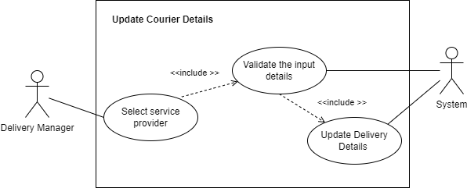

Figure B. 3 Use Case Diagram for Update Courier Details

|  |  |  |
| --- | --- | --- |
| Use-case Number | UC-16 | |
| Use-Case Name | Update Courier Details | |
| Priority | High | |
| Actor | Delivery Manager | |
| Description | This use case describes how Shop Manager update the courier details of the individual order | |
| Precondition | UC-15 | |
| Post-condition | If the use case was successful, Shop Manager can change the order status and the customer can view all the courier details. | |
| Basic course of Action | **User Action** | **System Response** |
| 1. Delivery Manager at individual order page.  3. Shop Manager Update Courier Details including Courier Company Name, Tracking Number, and Tracking Url and Click the “Update Courier Details” button. | 2. The system prompts the order details including shipping details.  4. System validates the fields  5. System Display massage the “Courier Details Update”.  6. Use Case exists. |
| Alternate course of Action | 4.1 System validates all fields are filled with the correct format. If not, the system displays necessary error messages. | |

Table B. 3 Use Case Narrative for Update Courier Details

* **Use – Case Diagram for Make Payments**

Use case diagram for make payments is given in Figure B.4 and use case narrative for make payments is given in Table B.4.

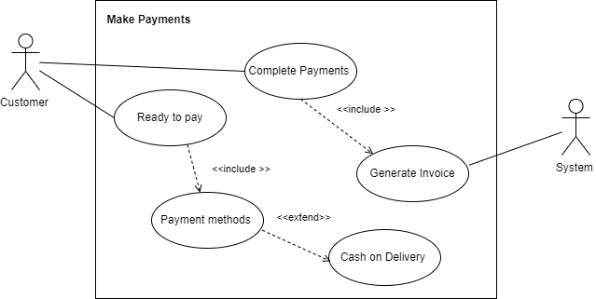

Figure B. 4 Use Case Diagram for Make Payments

|  |  |  |
| --- | --- | --- |
| Use-case Number | UC-14 | |
| Use-Case Name | Make Payments | |
| Priority | High | |
| Actor | Customer | |
| Description | This use case describes payment options for the customer | |
| Precondition | UC-13 | |
| Post-condition | If the use case was successful, the customer can select the payment method to place the order. | |
| Basic course of Action | **User Action** | **System Response** |
| 1. User in payment page  3. Actor selects the payment options cash on delivery and clicks “Pay Now” | 2. System prompts total payment and payment options.  4. System recode the payment method and redirect to thank you page. |
| Alternate course of Action | 4.1 System Prompt All order details and payment method on thank you page. | |

Table B. 4 Use Case Narrative for Make Payments

* **Use – Case Diagram for Check Items**

Use case diagram for check items is given in Figure B.5 and use case narrative for check items is given in Table B.5.

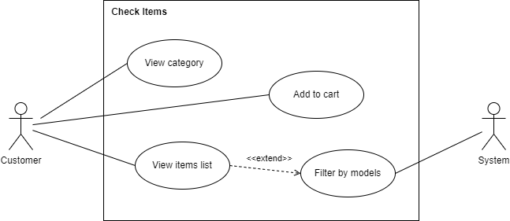

Figure B. 5 Use Case Diagram for Check Items

|  |  |  |
| --- | --- | --- |
| Use-case Number | UC-12 | |
| Use-Case Name | Check Items | |
| Priority | High | |
| Actor | Customer | |
| Description | This use case describes how the customer checks the items in the system | |
| Precondition | UC-08 | |
| Post-condition | If the use case was successful, the actor can check the items in the system. | |
| Basic course of Action | **User Action** | **System Response** |
| 1. User in category page. 3. User can select the category (Processors, Ram, VGA, Motherboard, Power Supply, Casing, Storage, Monitors, and Audio) and click the “View Category” Button.  5. User Click “View Item” | 2. System display all available categories.  4. System navigate appropriate category page and list all available items.  6. System navigate to the individual item page and display (Item Name, Item Short Description, Price, Item Features with Details.)  7. Use Case Exist |
| Alternate course of Action |  | |

Table B. 5 Use Case Narrative for Check Items

**Activity Diagrams**

An key diagram in UML for describing the dynamic features of the system is the activity diagram, which is simply a flowchart to represent the flow from one activity to the next. It is possible to classify the action as a system operation.

* **Activity diagram for Customer Registration**

The activity diagram for customer login is given in Figure B.6

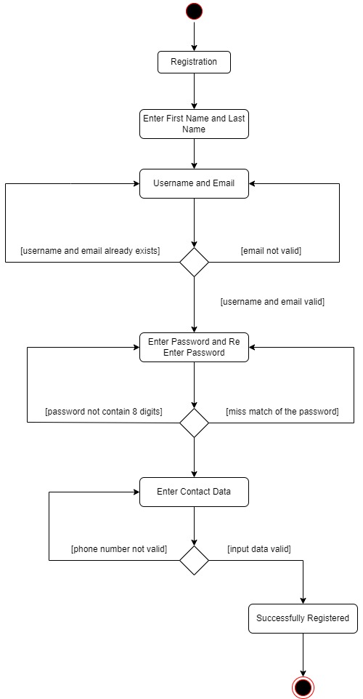

Figure B. 6: Activity Diagram for Customer Login

* **Activity diagram for** **Order Checkout**

The activity diagram for order checkout is given in Figure B.7

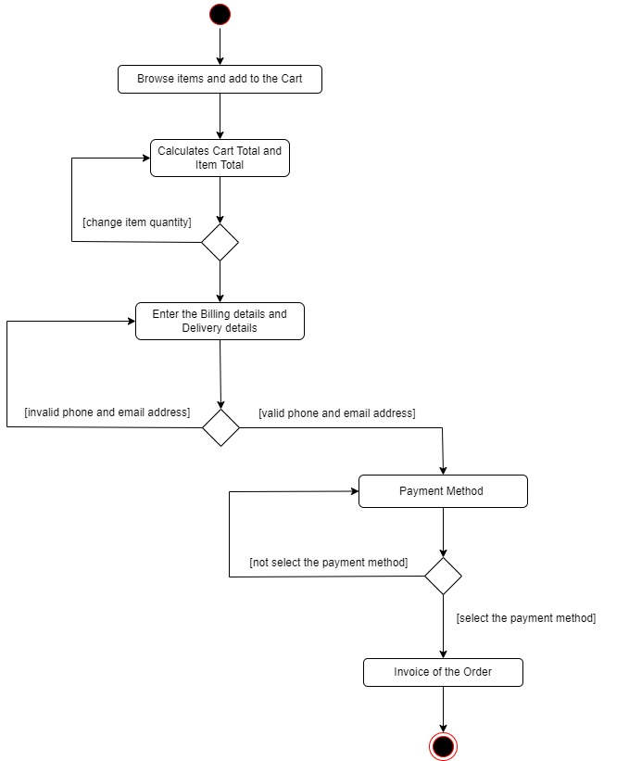

Figure B. 7: Activity Diagram for Order Checkout

* **Activity Diagram for Update Courier Details**

The activity diagram for update courier details is given in Figure B.5

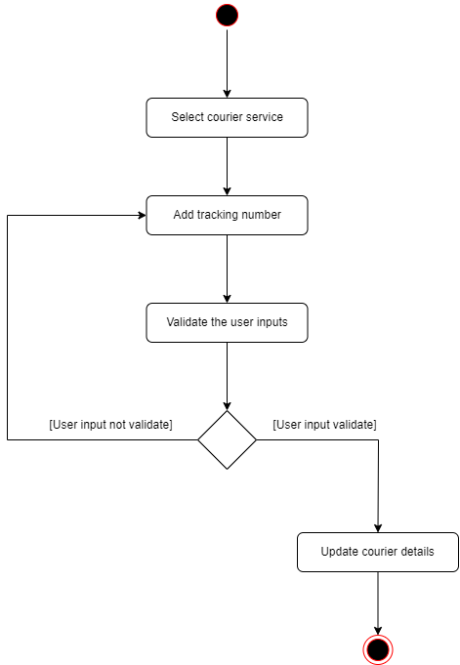

Figure B. 8 Activity Diagram for Update Courier Details

* **Activity Diagram for Make Payments**

The activity diagram for make payments is given in Figure B.9

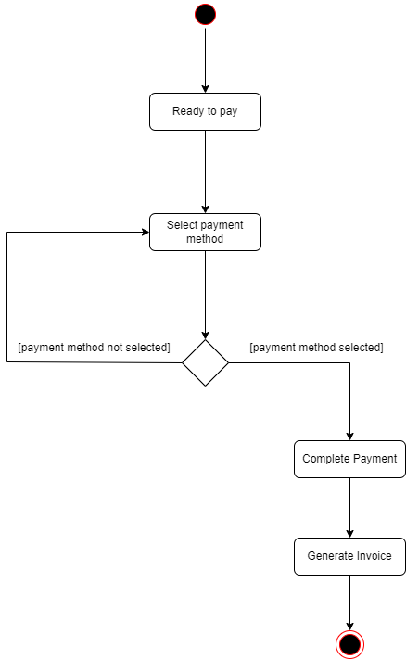

Figure B. 9 Activity Diagram for Make Payments

* **Activity Diagram for Check Items**

The activity diagram for check items is given in Figure B.10

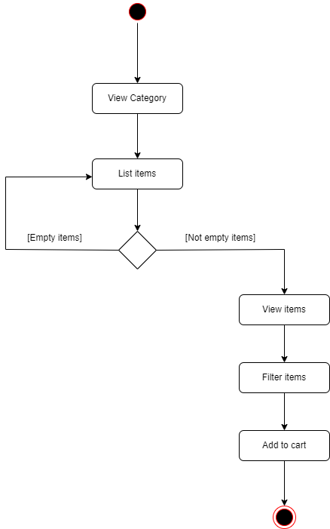

Figure B. 10 Activity Diagram for Check Items

# Appendix C – User Manual

By covering essential aspects, this manual provides the necessary instructions for Customers, Administrators, Shop Managers, Inventory Managers, Delivery Managers, and Technicians to interact with the system. This section's ultimate purpose is to make the user aware of the system's major features so that they can get the most out of it. Despite the fact that the system describes several user-level privileges, the key modules of the standard user role, Below is a brief description of various administrator setup options..

**User Manual Part 1**

**User: Customer**

Browse the home page of the U-Star Digital website by visiting the URL <http://localhost/ustar/> . (Figure C.1). Following the selection of the option, the consumer can proceed with the standard computer hardware shopping cart process as depicted in (Figure C.2) (Figure C.3) (Figure C.4) (Figure C.5) (Figure C.6) (Figure C.7)

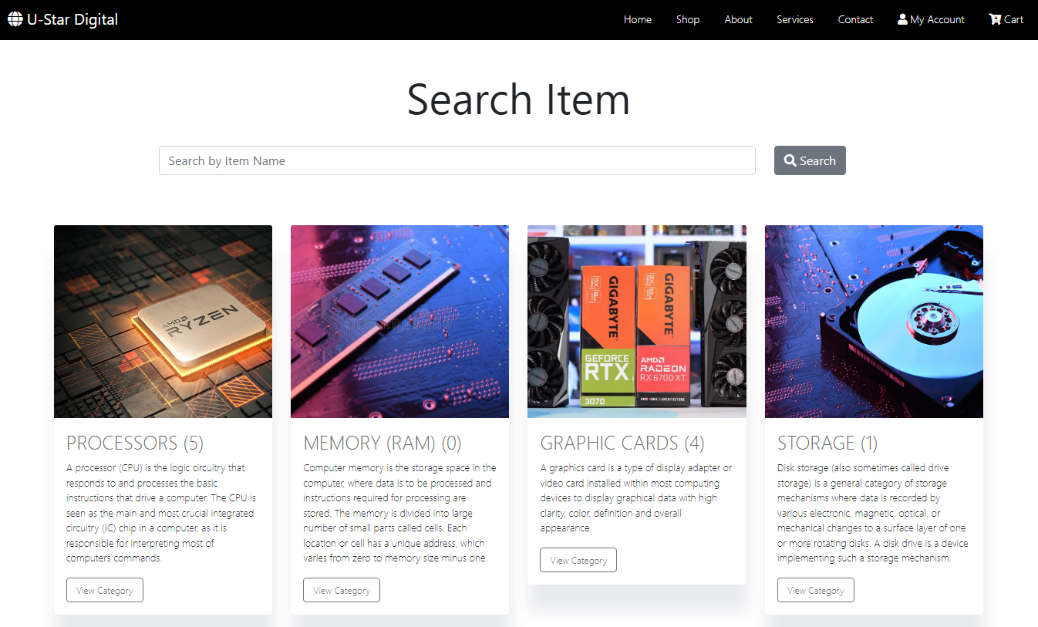

Figure C. 1: Home Page

Customers can start the shopping experience by selecting the category.

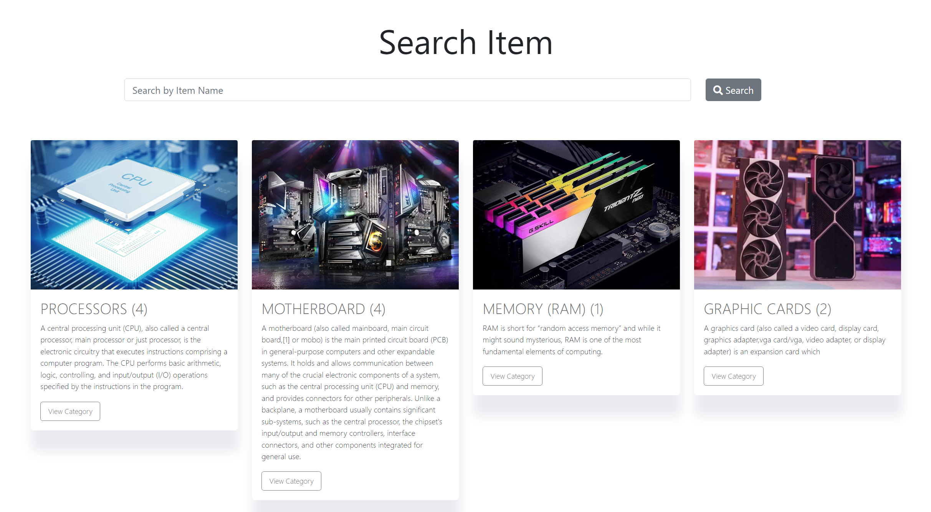

Figure C. 2: Category Page

After selecting a category customers can view the selected category product listing.

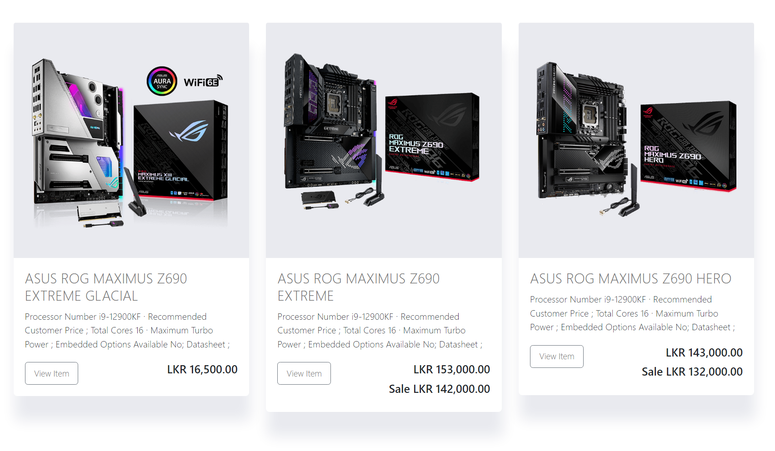

Figure C. 3: List Item Page

Individual item page for the selected item.

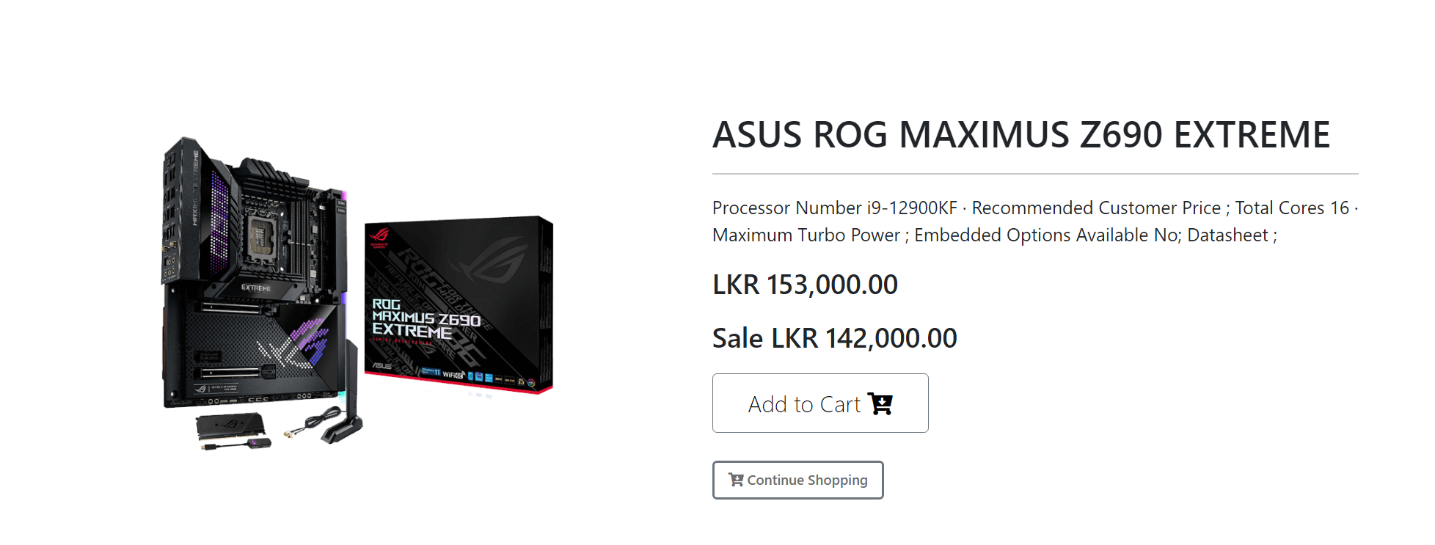

Figure C. 4: Item Page

Customers can check out the order through the cart page.

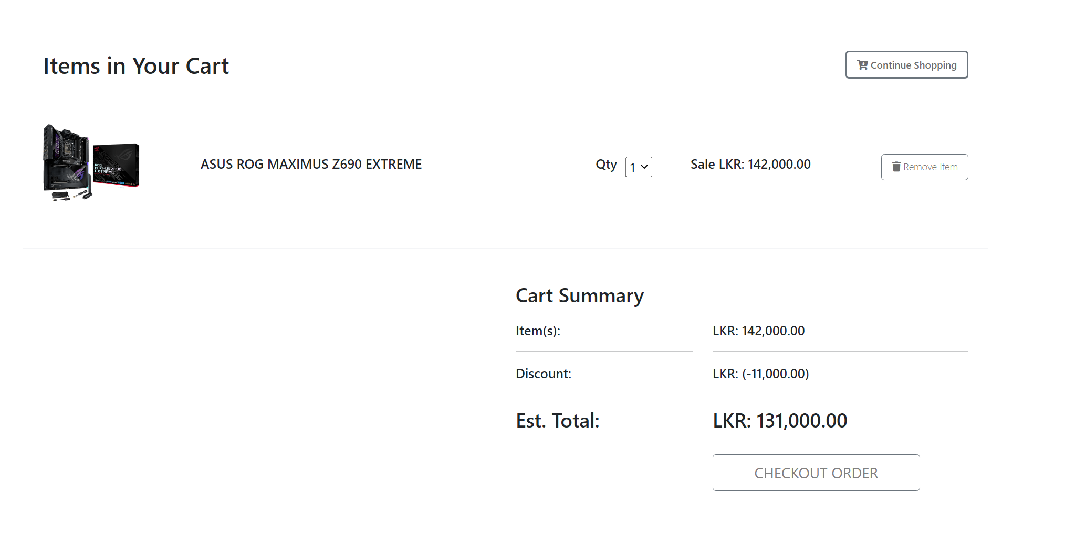

Figure C. 5: Cart Page

Checkout page to enter customer billing and delivery details.

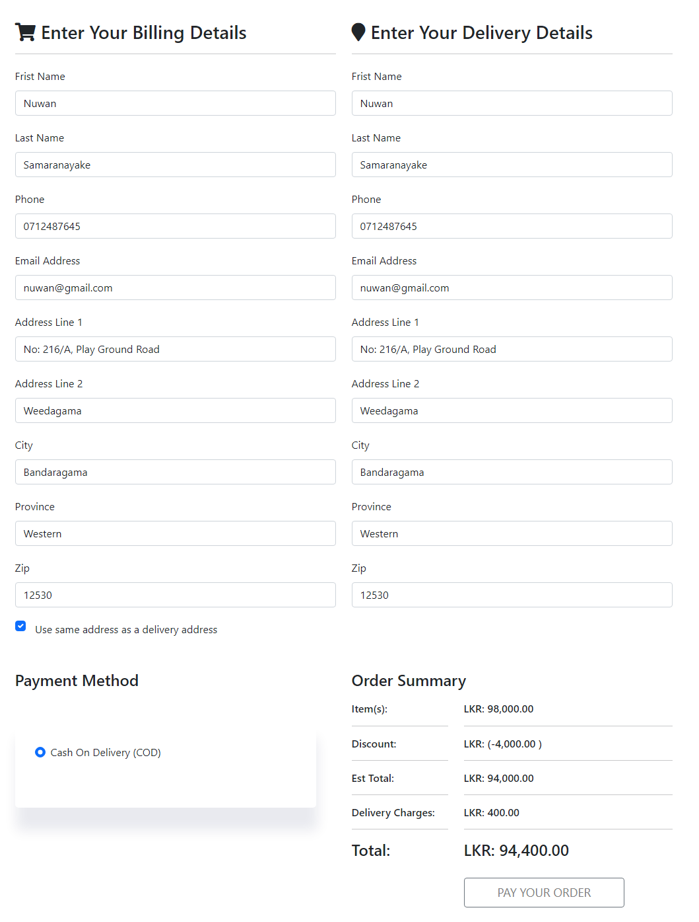

Figure C. 6: Checkout Page

Complete order by generating the invoice.

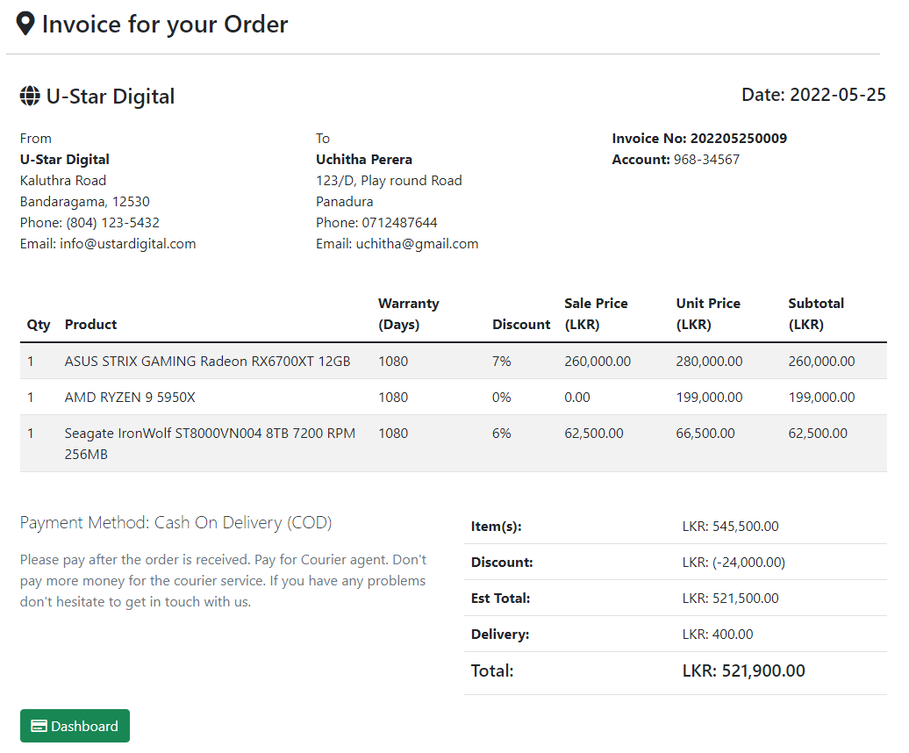

Figure C. 7: Invoice Page

**User Manual Part 2**

**User: Inventory Manager**

The inventory manager in U-Star Digital can handle the inventory items. To access the inventory manager dashboard, the inventory manager must use the <http://localhost/ustar/system/inventory/> URL.

After successful login, the inventory manager needs to add a category of the appropriate item. The inventory management process is depicted in (Figure C.8) (Figure C.9) (Figure C.10) (Figure C.11).

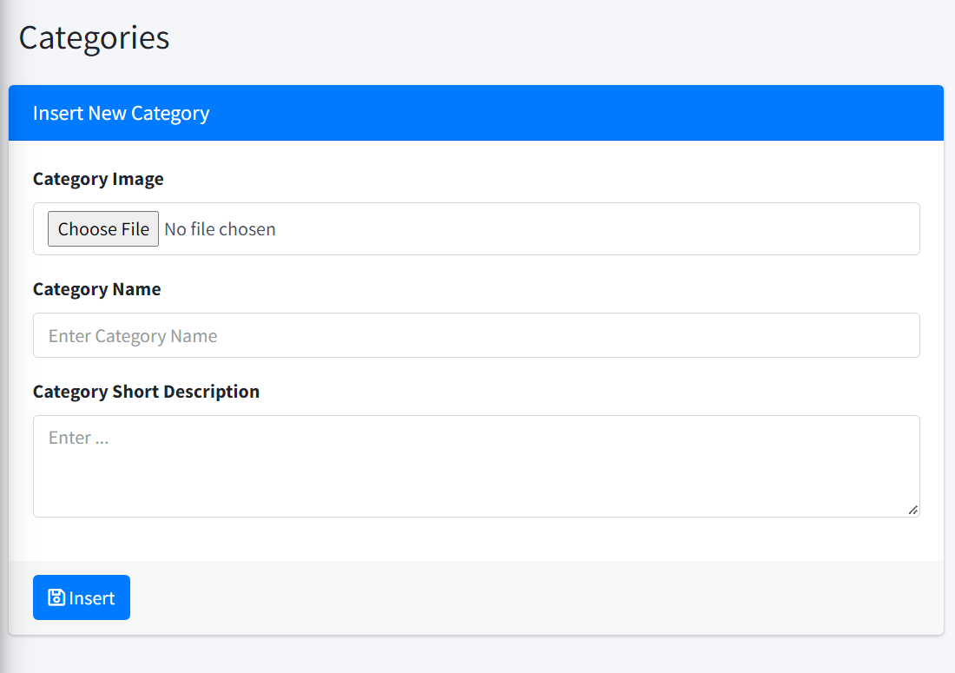

*Figure C. 8: Add Category Form*

Next need to add the appropriate brand of the item.

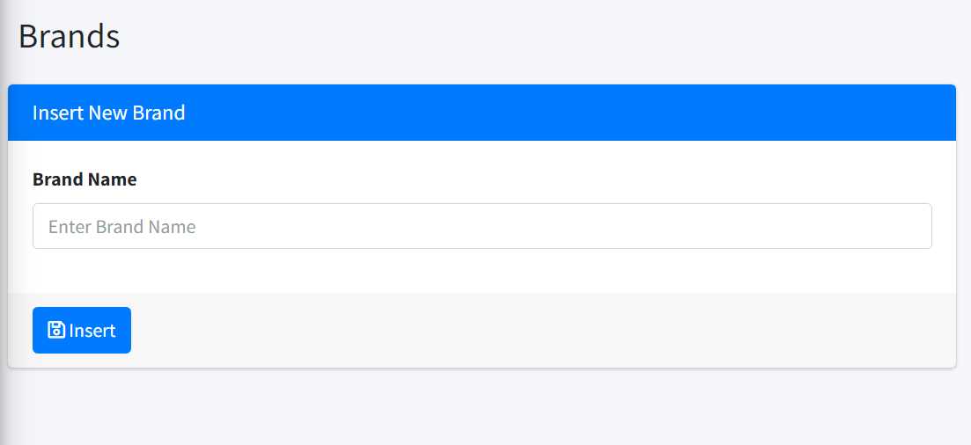

Figure C. 9: Add Brand Form

Next need to add the appropriate Model of the item.

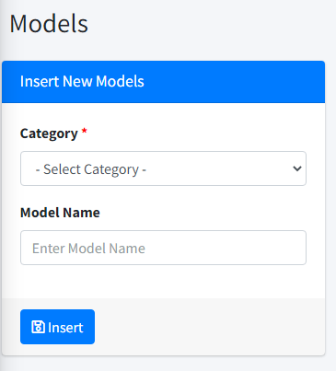

Figure C. 10: Add Models Form

Next need to add appropriate item details of the item.

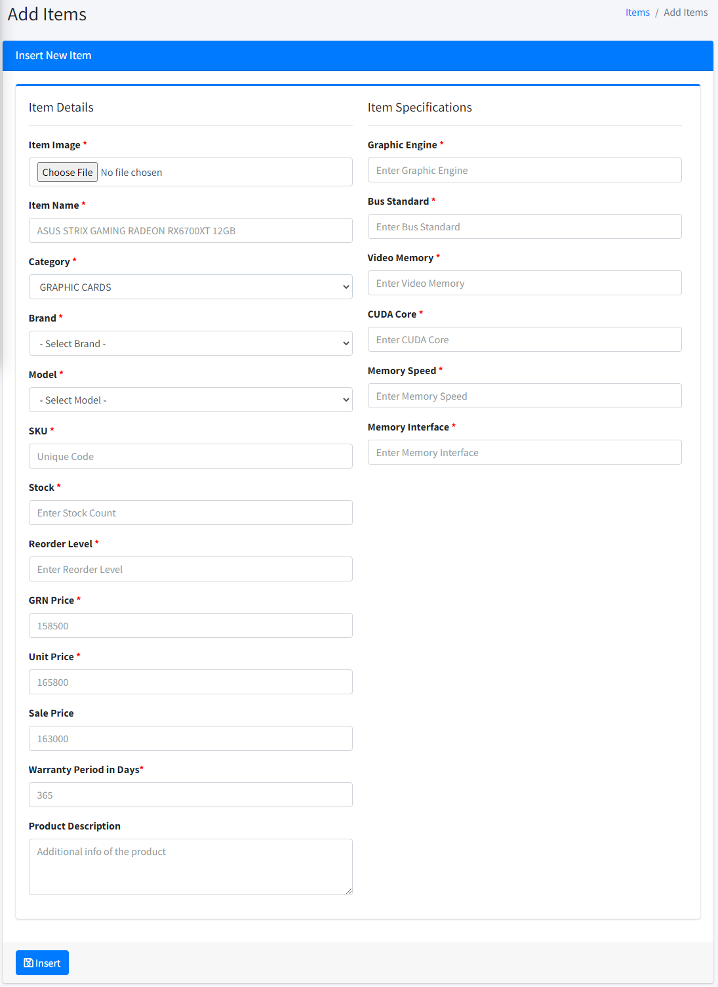

Figure C. 11: Add Items Form

**User Manual Part 3**

**User: Administrator**

The Administrator in the U-Star Digital can handle the users, user modules, and user roles. To access the Administrator dashboard, the Administrator must use the <http://localhost/ustar/system/> URL. After successfully login administrator can add users to the system.

The administrative procedure is shown in (Figure C.12) and (Figure C.13).

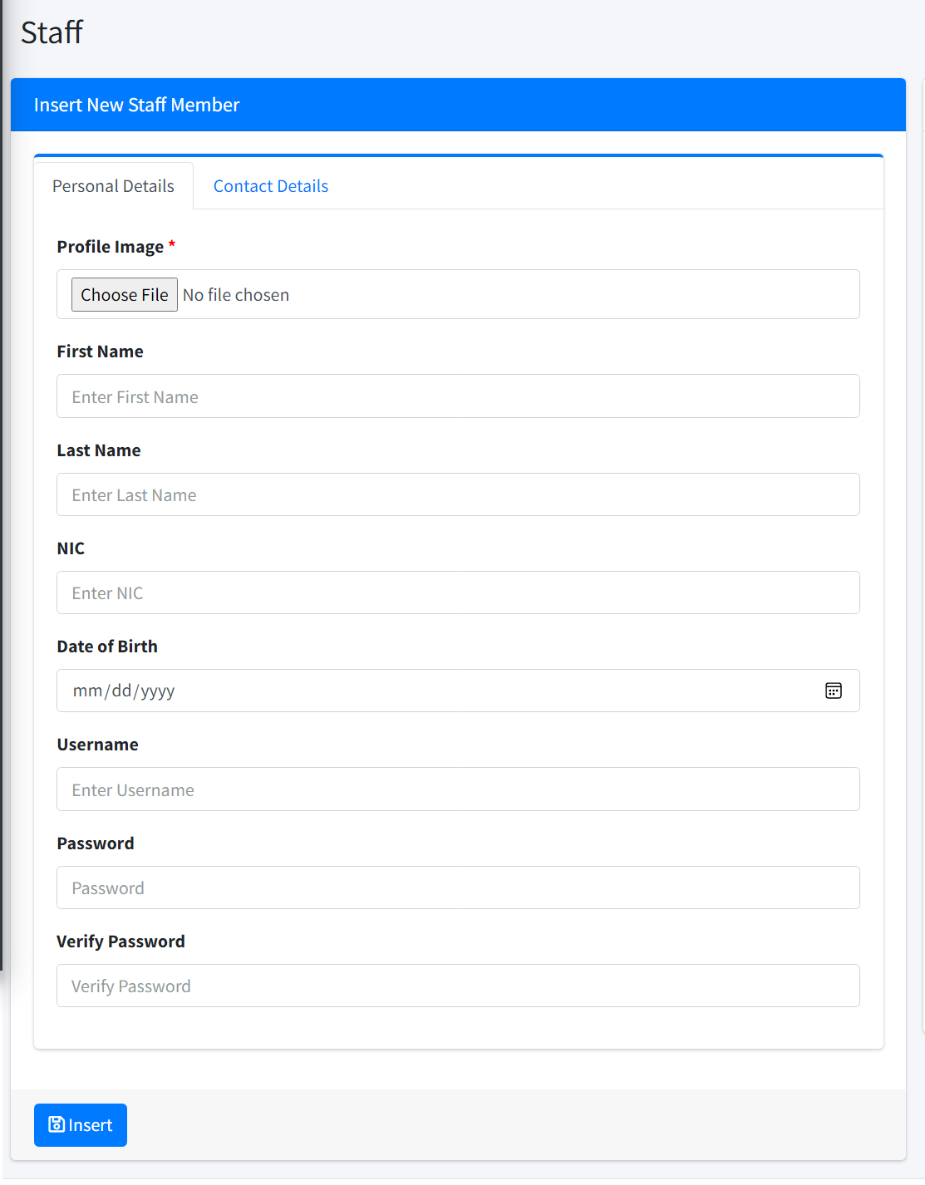

Figure C. 12: Add Employee

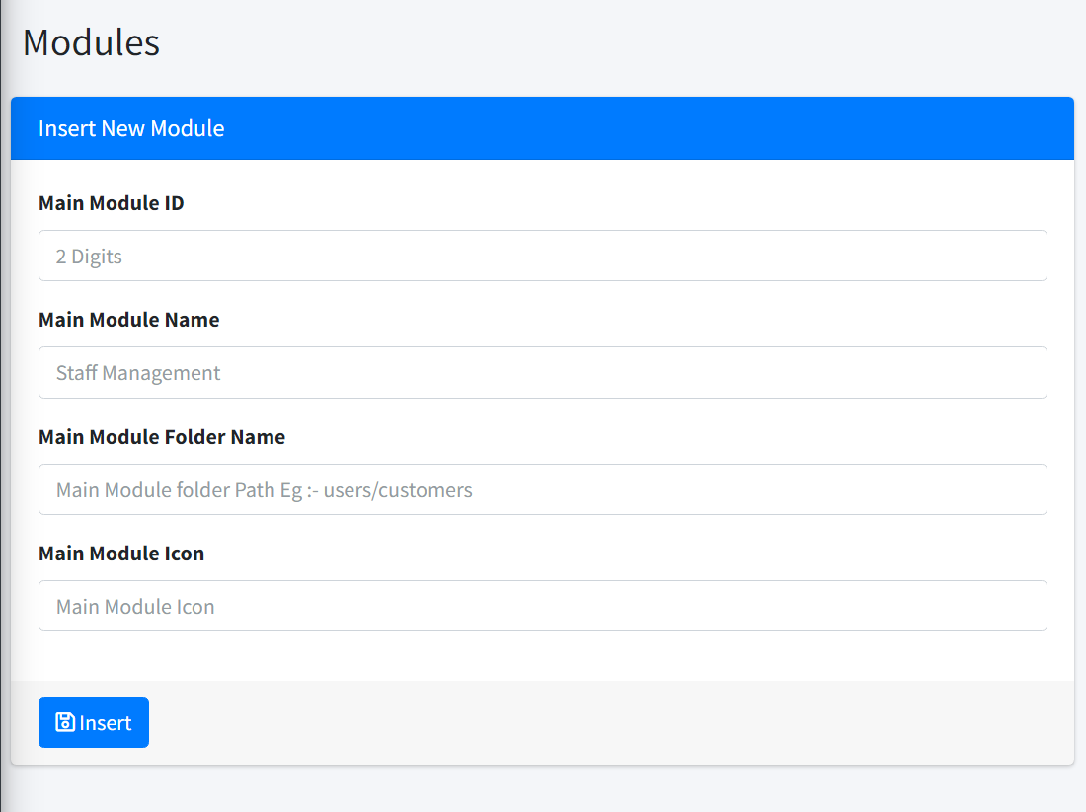

Figure C. 13: Add user modules

# Appendix D – Management Reports

The system may produce the following key reports, which are displayed below.

* **Revenue Detail Report**

Figure D.1 shows all the revenue report that the shop manager saw between May 17th and March 25th, 2022.

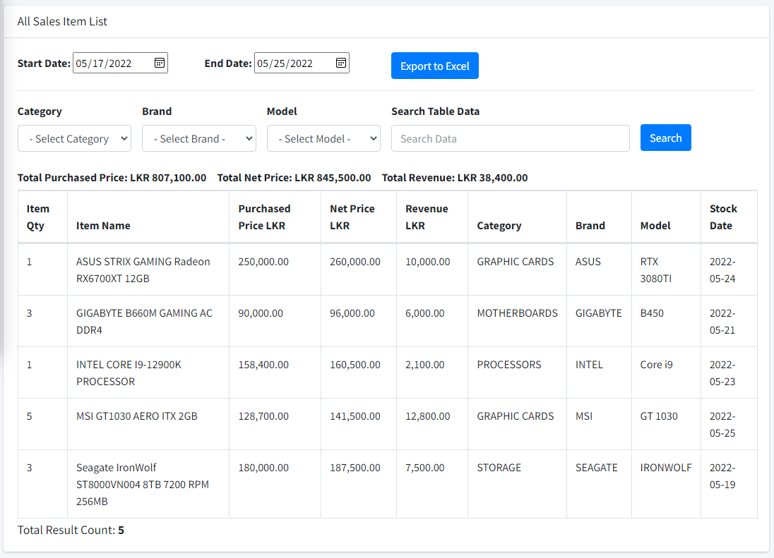

Figure D. 1: Report of Orders

* **Revenue Summary Report**

Figure D.2 was generated to view a summary of the revenue.

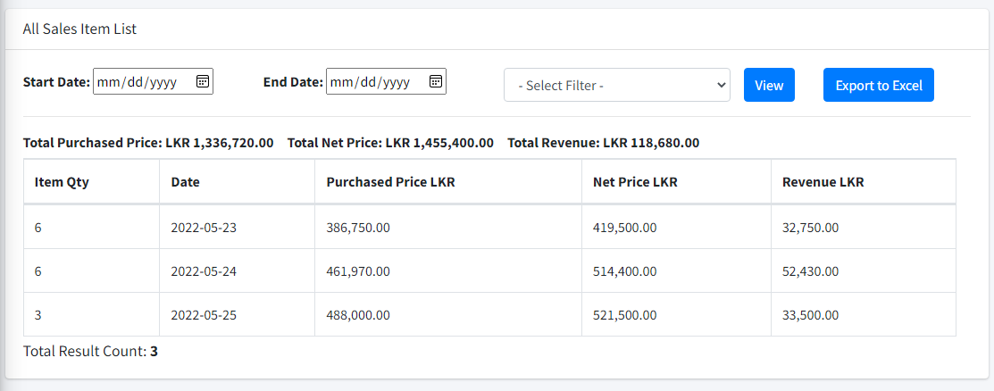

Figure D. 2: Report of Items

* **Delivery Report**

Figure D.3 was generated to view all delivered orders of the system.

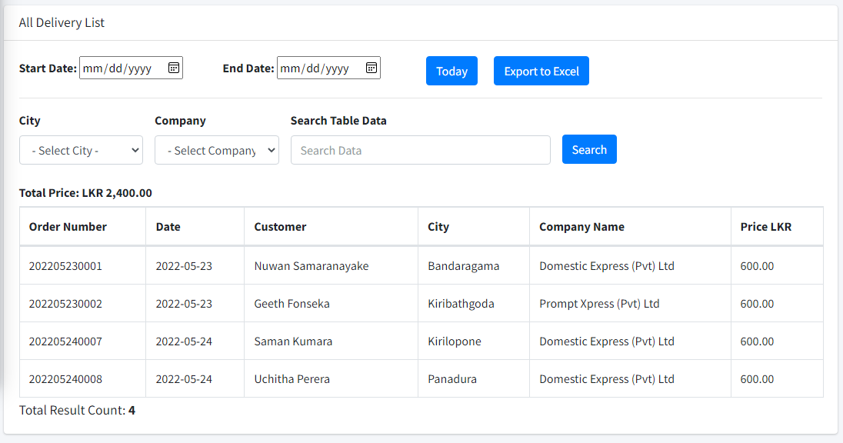

Figure D. 3: Report of Order Deliveries

* **Inventory Report**

Figure D.4 was generated to view all items in the system.

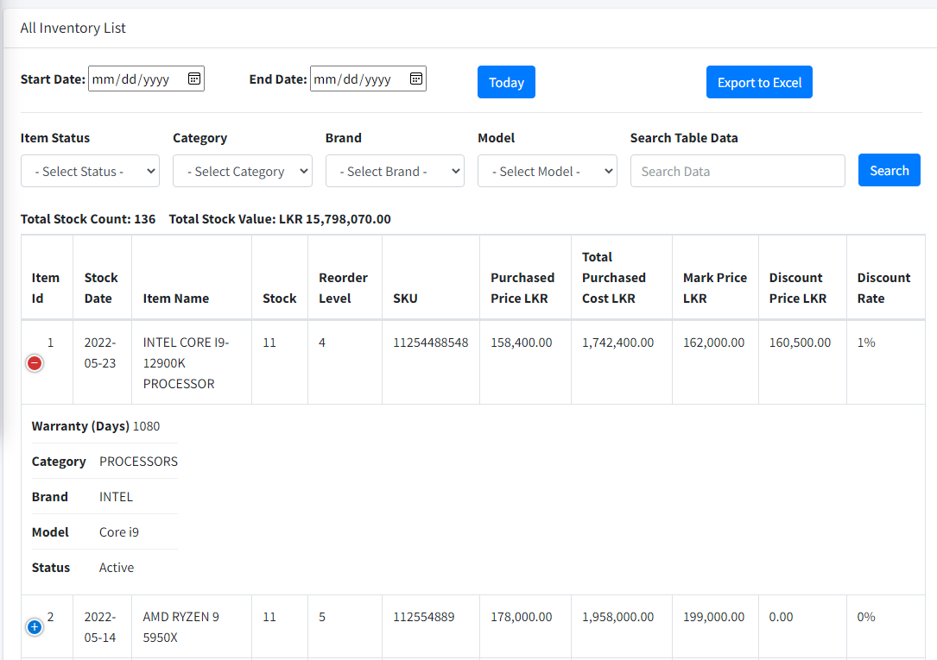

Figure D. 4: Report of Stock

* **Customer Report**

Figure D.5 was generated to view all customers in the system.

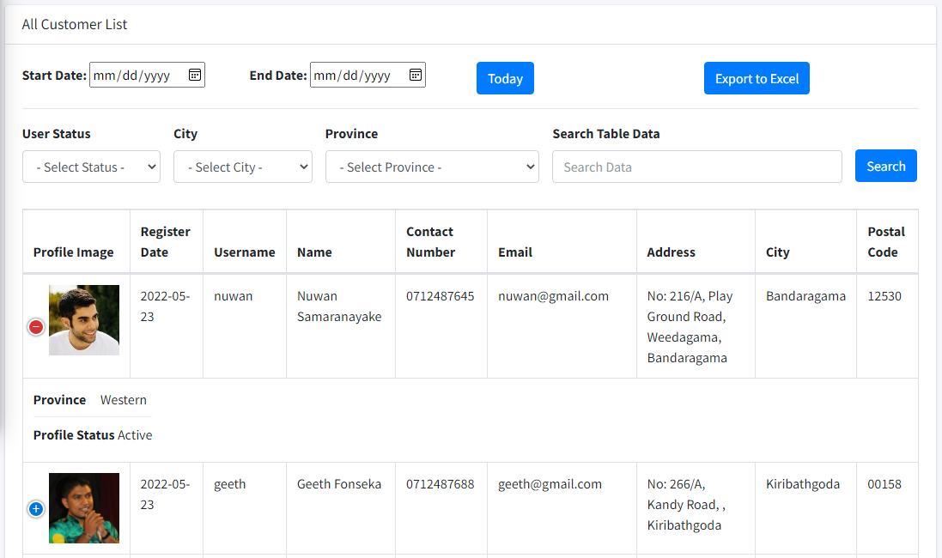

Figure D. 5: Report of Product Categories

# Appendix E – Test Results

**Test Result for Customer Registration**

Table E.1 shows test results of customer registration

|  |  |  |  |
| --- | --- | --- | --- |
| **Test No** | **Test Case** | **Expected Result** | **Actual Result** |
| 1 | Submit the form without filling in the mandatory fields. | Prevent submitting and show error messages |  |
| 2 | Use already exists username and email address | show error message |  |
| 3 | Enter already exists email address | show error message |  |
| 4 | Incorrect Password length insert | show error message |  |
| 6 | Invalid phone number insert | show error message |  |
| 7 | Enter the numbers in the text fields | show error message |  |
| 8 | Invalid zip inserts | show error message |  |
| 9 | Submit Correct Register Data | Navigate to the complete profile page |  |
| 10 | Submit the form with the correct data | Redirect to the login page |  |
| 11 | Without login URL browsing to the customer dashboard | Redirect to login page |  |

Table E. 1: Test Result for Customer Registration

**Test Result for Customer Login**

Table E.2 depicted the customer login test result

|  |  |  |  |
| --- | --- | --- | --- |
| **Test No** | **Test Case** | **Expected Result** | **Actual Result** |
| 1 | Enter valid username and password | Successful login to the system |  |
| 2 | Enter username only | show error message |  |
| 3 | Enter only password | show error message |  |
| 4 | Enter invalid username and password | show error message |  |

Table E. 2: Test Result for Customer Login

**Test Result for Checkout Process**

Table E.3 belongs to the test result of the system order checkout process.

|  |  |  |  |
| --- | --- | --- | --- |
| **Test No** | **Test Case** | **Expected Result** | **Actual Result** |
| 1 | Submit the form without filling in the mandatory fields. | Prevent submitting and show error messages |  |
| 2 | Enter the numbers in the text fields | show error message |  |
| 3 | Invalid phone number insert | show error message |  |
| 4 | Invalid zip inserts | show error message |  |
| 5 | Without check the delivery check box | Show error message of delivery form |  |
| 6 | Without selecting the payment method | Show error message |  |
| 7 | Change the delivery value related to the province | Show delivery charges and calculate to total |  |
| 8 | Submit the form with the correct data | direct to the invoice page |  |
| 9 | Without login URL browsing to the checkout and invoice | Redirect to the cart page |  |

Table E. 3: Test Result for Checkout Process

* **User Acceptance Test Results**

Figure E.1, Figure E.2, E.3, and Figure E.4 show the results of user acceptance testing.

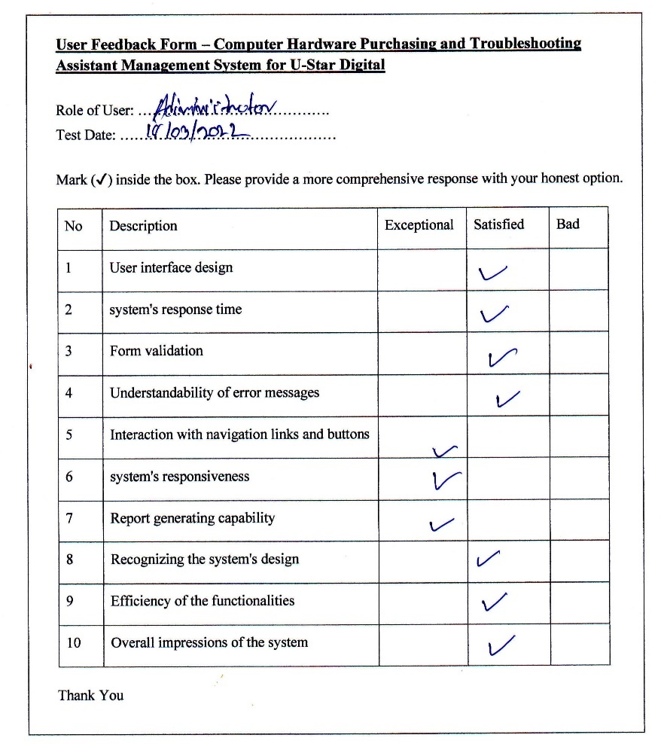

Figure E. 1: User Acceptance Test Result One

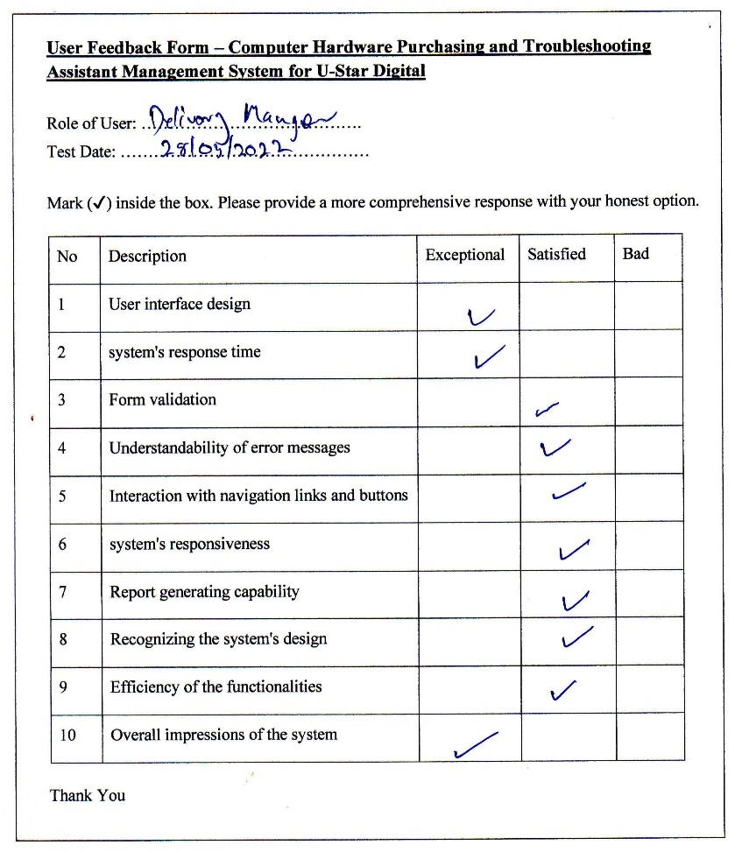

Figure E. 2: User Acceptance Test Result Two

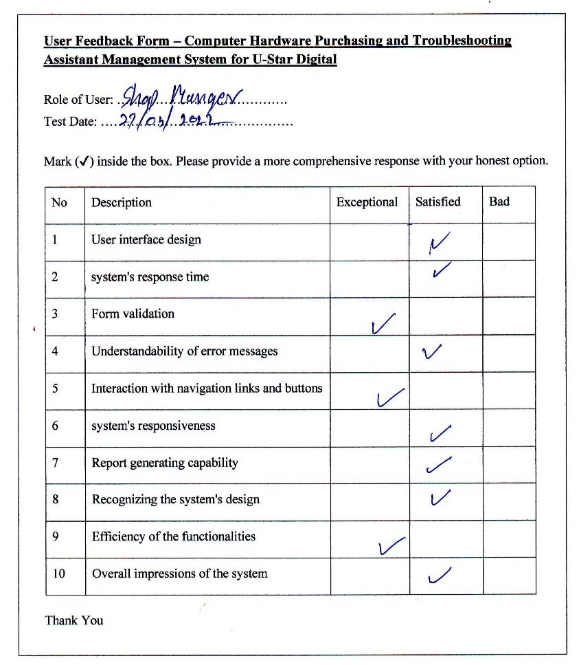

Figure E. 3: User Acceptance Test Result Three

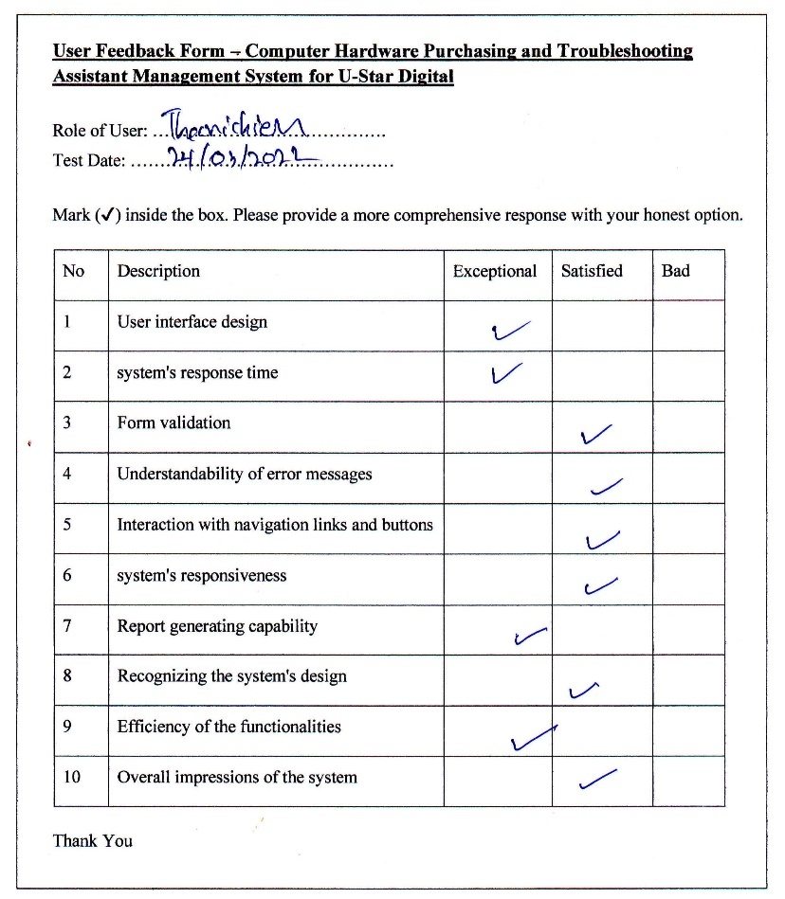

Figure E. 4: User Acceptance Test Result four

# Appendix F – Client Certificate



# Glossary

**AJAX** – Asynchronous JavaScript and XML is a collection of web development strategies that make use of a variety of web technologies.

**FIFO** – It is a cost flow assumption approach used in the computation of the cost of goods sold. The FIFO technique assumes that a company's oldest products have been sold first. The calculations are based on the prices paid for the oldest products.

**CSS** – Cascading Style Sheet is a style sheet language that describes how a document authored in a markup language should be presented.

**IDE** – IDE stands for Integrated Development Environment, which is a tool that allows computer programmers to develop, run, debug, and inspect their code.

**MySQL** – MySQL is an open-source relational database management system based on structured query language that is backed by Oracle.

**JavaScript** – An interpreted programming language. Use to create dynamic front-end developments.

**jQuery** – JavaScript library that is used in conjunction with HTML. It's a JavaScript library that's quick, tiny, and packed with features.

# Index

A

**AI** 48

Ajax 27

**AJAX** xii, 86

Apache iii, xii, 27, 28, 52

**application** 15, 28, 48

**assistant** 3, 48, 49

B

**BIT** xii

C

Cart 2, 8, 11, 68

**CD** xii, 53

Checkout 25, 34, 42, 43, 56, 57, 62, 69, 80, 82

computers iii, 1

CSS iii, xii, 27, 29, 35, 86

customers iii, 2, 11, 17, 49

Customers iii, 1, 6, 8, 9, 48, 66, 67, 68

D

database iii, 4, 15, 29, 48, 52, 53, 86

delivery iii, 1, 2, 3, 6, 42, 57, 69, 81

Delivery 3, 5, 8, 11, 17, 19, 30, 66, 76

Dissertation 3

documents iii, 28, 47

Documents 5, 6

E

**ER** xii, 21

Evaluation xii, 4, 39, 43, 45, 46

F

**FIFO** xii, 86

H

hardware 1, 2, 3, 6, 17, 27, 49, 66

Hardware i, 2, 10, 11, 15, 27, 28, 44, 47, 51

HTML iii, xii, 27, 29, 86

I

**IDE** xii, 27, 86

Interviews 5

Inventory 2, 3, 8, 11, 15, 17, 19, 20, 26, 30, 66, 70

J

JavaScript iii, xii, 27, 29, 35, 86

JQuery 27, 29

M

Microcenter 10, 11

MySQL iii, 27, 29, 52, 86

N

Newegg 11, 50

O

Observation 5, 6

order iii, 1, 2, 3, 5, 6, 8, 9, 10, 27, 35, 39, 56, 57, 62, 68, 70, 75

P

Payment 2, 8, 11

**PEB** xii

**PHP** iii, xii, 27, 29

**Proactive** 39

purchased 1

R

**Reactive** 39

Report 3, 9, 30, 44, 75, 76, 77

Requirements 5, 8, 9, 13, 51

**RUP** xii, 12, 13, 50

S

Scrum 12, 13

**Security** 10

**SQL** xii

student 47

T

technician iii, 1, 6

Techniques 5

**Test** 39, 41, 42, 43, 44, 45, 50, 78, 79, 80, 82, 83, 84

**troubleshooting** 3, 17, 48

Troubleshooting i, 2, 3, 9, 10, 11, 15, 27, 30, 44, 47

U

**UAT** xii, 43

**UCSC** xii

**UI** xii, 24, 25

**UML** xii

**URL** xii, 8, 42, 43, 51, 70, 73, 79, 82

Use Case 17, 19, 20, 54, 56, 57

U-Star Digital iii, iv, 1, 2, 6, 27, 44, 47, 70, 73

V

**Validation** 32, 33, 40, 50

**Verification** 40, 50

Visual Studio Code iii, 27, 51

W

web-based system iii

X

**XAMMP** xii, 52

**XP** xii, 12, 13

